

Southern California Edison
CS Re-Platform Project

CIM-CS-01 Business Master Data – Manage Business Partner
Customer Interaction Management
Business Process Design
Version 2.7

Table of Contents
1 Business Process Overview 5
1.1 Current Pain Points for Southern California Edison 5
1.2 Responsible Parties 6
1.3 Document Control 6
1.4 Terminology 7
2 Business Process Design 9
2.1 Business Partner Details 9
2.1.1 Business Partner Category and Name 9
2.1.2 Business Partner Role 12
2.1.3 Address Management 13
2.1.4 Identification Numbers 16
2.1.5 Payment Transactions 19
2.1.6 Preferences 19
2.1.7 Business Partner Type 20
2.1.8 Business Partner Relationship 20
2.1.9 Business Partner Hierarchy 23
2.1.10 Business Partner Creditworthiness 23
2.1.11 Business Partner Synchronization 24
2.1.12 Industry (NAICS) Code 24
2.1.13 BP Mass Maintenance 24
2.1.14 Marketing Attribute 25
2.1.15 Integration with Customer Self Service 25
2.1.16 Integration with Telephony Process 26
2.1.17 BP Number Ranges 26
2.2 Process / Performance Improvement 27
2.3 Prerequisites and Inputs 27
2.4 General Assumptions 28
2.5 Business Process Hierarchy 28
2.6 Process Flows 28
2.6.1 Business Partner Identification, Creation, BP maintenance 29
2.6.2 Business Partner Relationship 30
2.7 3rd Party and SCE Legacy System Integrations 32
2.8 Data Elements 33
2.8.1 All Categories 33
2.9 Cloud for Customer (C4C) Integration 34
2.9.1 Processes 34
2.9.2 C4C Views 34
2.9.3 Activity 36
2.10 Exception Management Requirements 36
2.11 Process Risks and Mitigation 37
2.12 Key Performance Indicators 37
2.12.1 Key Metric Definition 38
3 Controls, Regulatory Rules, and Security 39
3.1 Security Considerations 47
3.2 Custom Program/Transaction Codes 49
3.3 Custom Table/Transaction Codes 49
3.4 Data Criticality and Cybersecurity Baseline Risks 49
4 Technical Considerations 51
4.1 RICEF-W Assessment 51
4.1.1 Reports 51
4.1.2 Interfaces 51
4.1.3 Conversion 51
4.1.4 Extension/Enhancements 52
4.1.5 Forms 58
4.1.6 Workflows 58
4.2 IDEX Considerations 58
4.3 Production System Cut-over Considerations 58
4.4 Other Considerations 59
5 Change Management 60
5.1 Change Impacts 60
6 Requirements 72

This page intentionally left blank

Business Process Overview
The Manage Business Partner process will define how to create, change, and display Business Partner (BP, and is also referred to as an “Individual Customer or Account”) in Hybris Cloud for Customer (C4C) data within SCE SAP environment. Integration aspects between the BP and Contract Account (or “CA” in S/4HANA, is also known as a “Contract Account” or “CA” in Hybris C4C).

Whenever a BP is created from Hybris C4C, one mailing address must also be created for that BP. Business Partner Address within Hybris C4C is defined as two types - Mailing Address and Service Address. Mailing Address is exclusively contained within BP and is referenced by the Contract Account, whereas the Service Address is exclusively contained within the Connection Object and Premise Objects.

BP relationships (i.e. Partner Contact or Contact) are utilized to model relationships between two or more BP’s. Hybris C4C rationalizes the relationship categories as a Partner contact that are utilized & can be different between the ‘Person’ and ‘Organization’ BP categories. While the relationship between persons will typically define how these BP’s directly relate to each other, such as spouses, parent / child or roommates, the relationships between a person and an organization define the Partner contact person for that organization, such as an office manager or account manager. BP relationship from Hybris C4C can be created as a New Partner relationship.

Business Partner preferences, like email, phone number, SMS/text, etc. for notification purposes, will be stored at the Business Partner level to allow SCE customers to receive the preferred notification based on the notification category they have chosen.

Current Pain Points for Southern California Edison
- Currently SCE doesn’t hold any Object with centralized information to store Customer Information
- 360 degree view of customer is not available resulting agent to consume more time.
- No Data Synchronization Responsible Parties
- Many duplicate Business Partners that need to be consolidated
- Some Business customers categorized incorerctly as individual customers (Person vs Business) and vice versa
- Bad/Obsolete data regarding communication methods - not maintained in CSS
  - Customer contact information (email, phone, SMS, TTY and mailing addresses) and notification preferences are stored in multiple systems today which are not integrated and kept in synch. This can result in non-compliance with TCPA and CAN-SPAM laws, customer dis-satisfactoin and unnecessary costs.
- Customer contact information is not validated on a regular basis to ensure we have good contact information for electricity related communications (e.g., pending disconnect), safety (e.g., outage alerts), program alerts (e.g., DR events) and identification processes (e.g., caller ID in IVR).
- Limited data synchronization with SCE.com

Responsible Parties
Contact | Contact Person
Southern California Edison Business Process Owner | Christine Evans
Southern California Edison Lead | Christine Evans
HCL Functional Lead | Adrianus Halim
Solution Architect | Pedro Ferreira da Costa
Front Office or Back Office Lead | Christine Evans
Subject Matter Experts | Christine Evans  Cari Young  Ernesto Valle  Pedro Costa  Natalie Martinez  Frank Starke  Deborah Tillman  Scott Hirth  Janine Aumont
Key User Group | Customer Contact Center (CCC)  Business Customer Division (BCD)  Customer Products and Services (CP&S)  Credit and Collections (CAPS)

Document Control
Version | Description of Change | Date | Author
1.0 | Creation of Initial Version | 08/18/2017 | Adrianus Halim
1.1 | Draft Version with Workshop update | 10/11/2017 | Deepak Kumar Sinha
1.2 | Visio flow added and content modification | 11/14/2017 | Deepak Kumar Sinha
1.3 | Hybris C4C Business Functionality Added | 12/29/2017 | Deepak Kumar Sinha
1.4 | Final clean up after meeting with SCE | 2/2/2018 | Jessica Marsillo
1.5 | Updated RICEFWs based on C4C standard | 2/7/2018 | Jessica Marsillo
1.6 | Business Changes | 2/11/2018 | Cari Young
2.0 | Updates from Business | 2/13/2018 | Jessica Marsillo
2.1 | Updates from BPD Walkthrough | 2/17/2018 | Jessica Marsillo
2.2 | Additional updates from BPD Walkthrough | 2/21/2018 | Jessica Marsillo
2.3 | Updates from Business | 04/24/2018 | Jessica Marsillo
2.4 | Updates from Business | 05/08/2018 | Jessica Marsillo
2.5 | Updates from Business | 05/10/2018 | Jessica Marsillo
2.6 | Updates from Business | 05/25/2018 | Jessica Marsillo
2.7 | Aligning BPD with SCCs | 06/18/2019 | Jessica Marsillo

Terminology
Term/Acronym | Definition and SAP Equivalent (if applicable)
APSE | Accelerated (or Axon) Project Support Environment
BDEX | SAP add-on functionality to support the processing of BPEM Cases
Billing Cycle | Is a group of contracts to be billed together via date-driven or regional criteria, it controls the billing cycle and is linked to the Meter Reading Unit. SAP equivalent term is the Portion.
Billing Document | A document that outlines the charges incurred for energy consumption for a specific contract. During the process of Billing, a billing document is generated for each contract on a contract account.
BMD | Business Master Data. The customer information which includes personal details, payment terms, dunning levels, billing rates and rate categories. The business master data objects are Business Partner, Contract Account and Contract.
BWR | Basic Work Request. SAP equivalent is BPEM.
CA | Contract Account
Channel | Data object in SAP that holds the interval data. Intervals can be kwh, price, factor, etc. SAP equivalent is Profile.
Clarification | A list of payments that could not be processed and require additional work in order to be posted.
Connection Object | Link between installation and postal regional structure. Usually a building, but can also be a piece of property or other facility, such as a fountain or construction site. The connection object corresponds to the functional location in plant maintenance (PM).
Customer | Any entity with a relationship with SCE. This term is usually used in reference to customers (both individuals and organizations) This can include employees and third party suppliers (banks and payment partners). SAP Equivalent is Business Partner (BP)
BPD | Business Process Design (or Document)
BPEM | Business Process Exception Management
EAM | SAP Enterprise Asset Management
FOP | Front Office Process – This can be series of required steps triggering certain transactions to complete defined process
Hybris C4C | SAP Cloud for Customer Solution
IMG | SAP Implementation Guide - where configuration is performed
Level Pay Plans | SAP equivalent term is Budget Billing. Budget Billing allows customers to pay regular equal amounts over a yearly period.
S/4HANA | SAP HANA 4 Business Suite
SCE | Southern California Edison
Summary Billing | Standard SAP functionality that enables the invoicing of multiple Contract Accounts under one Parent Contract Account (Consolidated Summary Billing). SAP equivalent is Collective Billing.
TMD | SAP Technical Master Data e.g. Connection Object, Premise and Device Location
Additional terms may be found in APSE General Document # 32 CSRP Glossary

Business Process Design
The Manage Business Partner process will define how to create, change, and display Business Partner (BP) data within SAP environment. Business Partners will be created only one time with basic information such as name, mailing address, phone and e-mail addresses. Additionally, it holds banking information and personal identification such as Social Security Number, Driver’s License, Tax I.D., or State I.D., that will be secured with access available to only those needing the information to perform their job. Customer preferences containing contact methods (e.g. Voice, Text, Email, TTY, and Mail) for a particular notification category are also being stored and maintained as the preferred communication channel. Business Partners can be created, changed and displayed.

Business Partner Details

Business Partner Category and Name
The business partner category denotes whether a business partner is a Person, Organization or Group. The category selection is mandatory whenever a business partner is required to be created in the system and cannot be changed once saved. Depending on the category, certain information listed below will have to be filled with data like the following (other fields will be detailed in Section 2.8):
- Person (A natural person or Individual),
- Organization (Legal Entity, LLC, or Corporation), or
- Group (Collection of Business Partners)
(NOTE: The category Group is currently not used in SCE, but will be available for future use)

Person or Individual Customer
The Person Business Partner has several data elements which a user can enter to better identify the attributes of the Customer. The only data elements which are required are the First and Last Name as well as the Mailing Address, all other fields are optional.
  - Title (optional)
ID | Description | Person | Organization | Group
0001 | Ms. | X
0002 | Mr. | X
0003 | Company |  | X
0004 | Mr. and Mrs. |  |  | X

  - First and last name is required for BP Persons.
  - Other name components as optional (NOTE: SAP standard provides flexibility to configure below fields)
    - Known As
For example, if the BP’s name is Joseph and they go by Joey, this field will should be utilized. Please note that the name entered here is not searchable.
    - Academic title (eg. Dr., Prof., MBA, etc.) ,
ID | Academic Title | Description
0001 | Dr. | Dr
0002 | Prof. | Professor
0003 | Prof. Dr. | Professor Dr
0004 | B.A. | Bachelor of Arts
0005 | MBA | Master of Business Administration
0006 | Ph.D. | Doctor of Philosophy

    - Correspondence Language
This is used for correspondence with the BP (only with BP Person). The system will default to English but allow the user to update it.
    - Language
This is used for verbal communication with the BP. The system will default to English but allow the user to update it.

Organization or Group Business Partner
The Organization and Group Business Partners also have several data elements which a user can enter to better identify the attributes of the Customer. The only data elements which are required are the Organization Name, Legal Form, as well as the Mailing Address, all other fields are optional.
  - Form of address (optional, as shown in Person or Individual Customer above).
  - Organization name (required, SAP standard functionality has set the field Name as mandatory)
  - Legal form (optional) (e.g. Stock corporation, Limited Partnership, etc.)
This is only available in the category Organization and this denotes certain legal forms that are of significance for the organization of a company. This is configurable and used for information purposes only.
ID | Description | Short Name
01 | Corporation | Corporation
02 | Limited Liability Corporation (LLC) | LLC
03 | Partnership | Partnership
04 | Sole Proprietor | Sole Proprietor

  - Legal Entity (optional) (e.g. Public Sector Bank, Municipal Associations), this is only available in the category Organization and this refers to a legal entity that is responsible for the company. This is configurable and used for information purposes only.
ID | Name | Private Law
01 | Public Sector Bank
02 | Private Law Bank | X
03 | Private Law Company: Insurance
04 | Private Law Company: Industry
05 | Other Body of Public Law
06 | Municipal Body
07 | Rail
08 | Mail
09 | Public Law Bodies
10 | Private Law Property Companies

When creating or updating a BP, a user can optionally add the BP’s social media handles, including Facebook, Twitter and YouTube, as well as a website address.
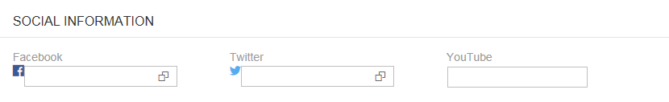
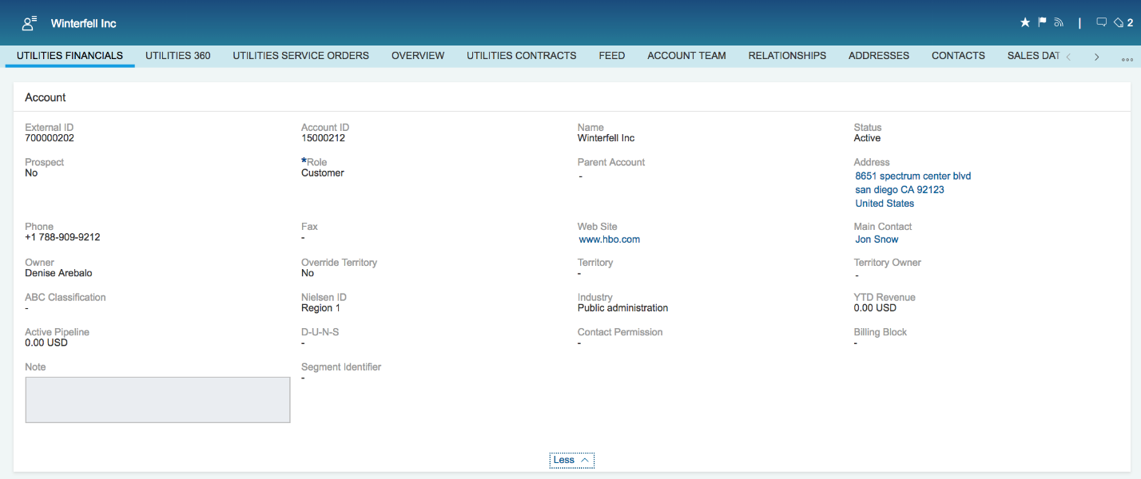
Figure 1 – Add Social Media Handles and Website Address

Industry Type
When the user is creating an Organizational BP, the Industry Type can be defined at the Contract Installation level.
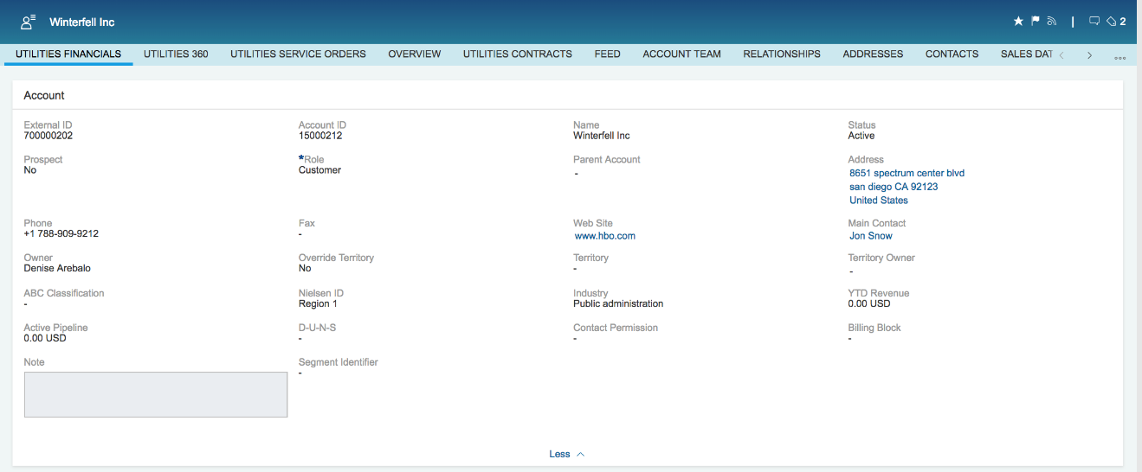
Figure 2 – Industry Type

Search/Sort
A user may search for a BP using any of the searchable fields as identified in APSE Action #55. (Standard SAP searchable fields for business partner). The user can choose to display inactive, active, or all. Active is the default. Additionally, the user has capability to filter or sort their search results.
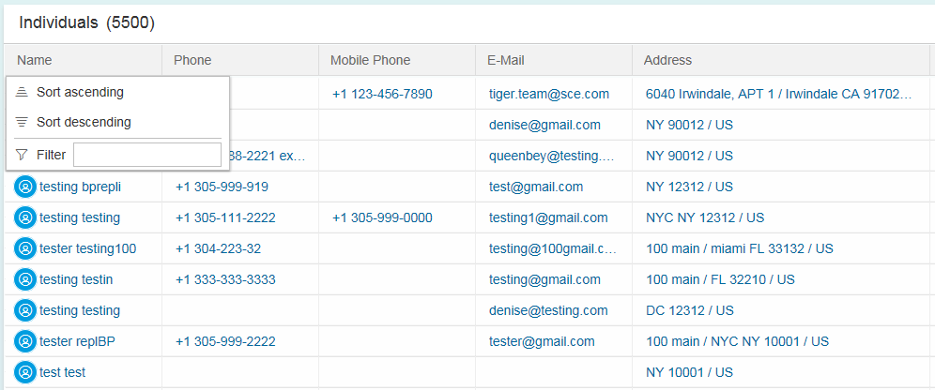
Figure 3 – Sort and Filter Search Results
Once the user selects an option from the search results and is taken to an assignment block, they can then “Jump to Top” or navigate to a difference assignment block by using the “Go To” feature in Hybris C4C.
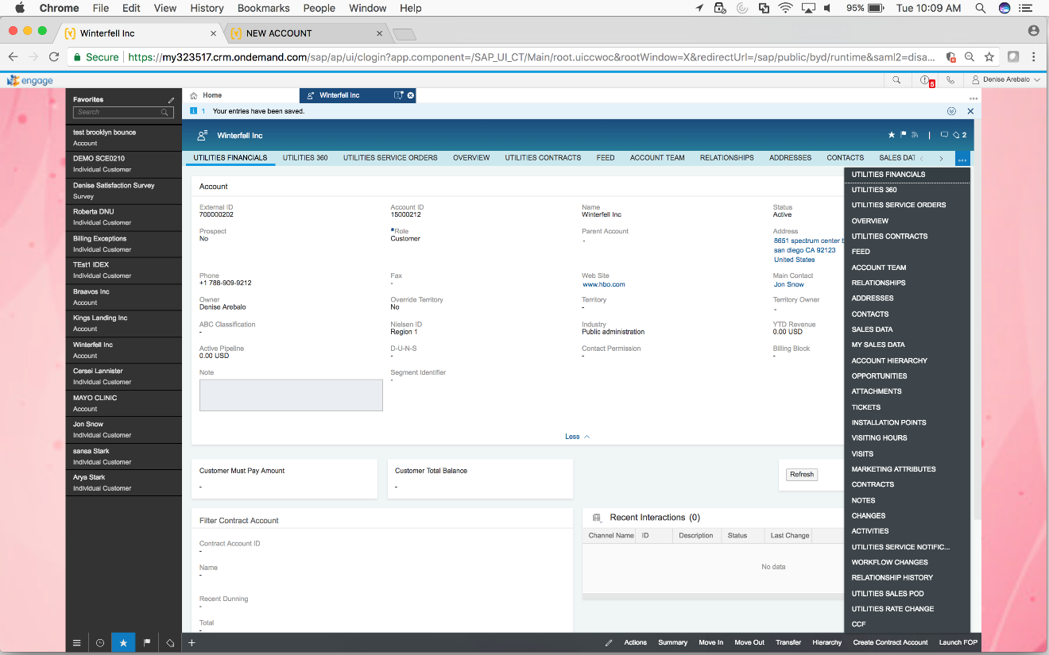
Figure 4 – Navigating Assignment Blocks

Business Partner Role
When a Business Partner (BP) is created in SAP, the BP can assume a number of roles to indicate the relationship between the BP and SCE. At a minimum, the BP will have the role of ‘Contract Partner’ and ‘Credit Management’, but once the BP is created, the role can be modified or can be assigned additional role types. The BP will have a single unique identifying BP number and this record stores all of the centralized data about the BP, but the BP will exist in multiple roles. This reduces the amount of maintenance required against the BP and helps prevent data inconsistency. Depending upon the process that is used to create the BP, the applicable role(s) can manually be added to the BP during maintenance. During migration, when a BP is created in S/4HANA, that same BP record will be assigned to a role.
If a BP is initially created as a Contract Partner and Credit Management, any additional role can also be added at a future point in time or removed. If a user wants to indicate a newly created Business Partner as a Contact Person only, the user would need to navigate to the Roles screen, add the Contact Person Role prior to removing the Contract Partner and Credit Management Roles.
Contract Partner (MKK) - A BP with the role of Contract Partner signifies that this BP is responsible for service charges and will be created with this role whenever they request service. Unless the BP has this role, that BP cannot be used during the New Contract process, which is described in detail within the BPD CIM-CS-02 - Handle Move-In/Out - Process Move-In (Process Start) document.
Contact Person (BUP001) – When a contact is known for a BP (typically for a BP with the Category of Organization, e.g. the finance manager for a retail store), that contact will be created as their own unique BP and assigned the role of Contact Person to track their contact information, such as phone numbers or email addresses. For that Contact Person that also exists as a Contract Partner, the role of Contact Person will just be added to their existing BP record.
Prospect (BUP002) - Business Partner is considered as Prospect when it shows some interest in services, but is not currently a customer of Southern California Edison (does not have a contract account or contract). In other words, Prospect is defined as a Business Partner interested in conducting business or by which such an interest is assumed.
Employee (BUP003) - Any employee who requires access to the Front Office will be created as a BP with the role of Employee, unless that employee already exists as a Contract Partner, then the Employee role will just be added to the existing BP record. The Employee role enables assignment to the SAP HR Organization Structure for Front Office assignment along with Front Office Business Role assignment. When a BP has the role of Employee, the attribute ‘User Name’ (maintained on the Identification tab) will be populated with the SAP user ID for that BP. This attribute is used to link Front Office activities (e.g. creation of follow up activities) for the BP to any back office activities (e.g. case management) for that user. Any person who has been identified as an authorized user for an external agency and will be granted limited access to the Front Office and will be created as a BP with the role of Employee. If this person already exists as a BP, the role of Employee will just be added to their record and their SAP ID added to the User Name field. These external ‘employees’ will be subject to the same data access restrictions that exist for NFG employees.
Financial Service / Credit Management (UKM000) - For every BP with the role of Contract Partner, the role of BP Credit Management (as used in ECC) will also be utilized for that BP. The BP Credit Management role is used to store and manage all Credit Risk Management data for the BP, such as the internal and external credit scoring for the BP. For additional information about the use of this role, refer to the BPD CC-FI-21 - Manage Credit - Credit Score document.
SAP Standard offers:

Address Management
There are two types of addresses that will be stored and managed; Mailing Addresses and Service Addresses. As seen in Figure 5 below, the Mailing Address is exclusively contained within the BP and is required to create a BP and is referenced by the Contract Account, whereas the Service Address is exclusively contained within the Connection Object and Premise.
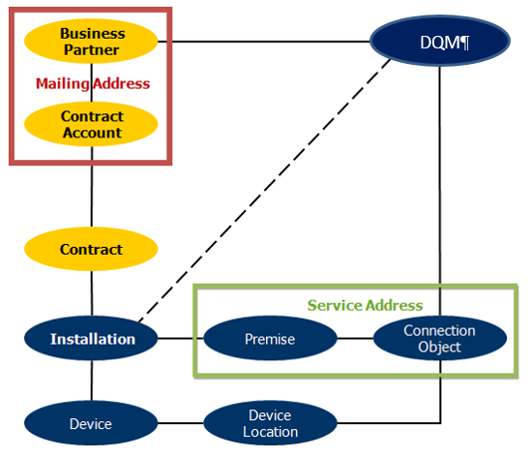
Figure 5 – High Level Data Model
When the initial address is created for the BP, it also becomes the Standard Address for the BP, which will also become a default mailing address for all correspondence sent to every Contract Account for that BP. There is no limit to the number of addresses that can be tracked for the BP; however any subsequent address created for the BP is just stored for the BP as an additional address, unless it is explicitly set to become the new Standard Address for that BP. Users can indicate if the mailing address at the Contract Account shall be fixed, this ensures that the address selected for that particular Contract Account is not updated when the BP Standard Address is modified. Any address can be deleted from the BP’s record except the Standard Address. In order to delete the Standard Address, another address must be identified as the Standard Address first, which then makes the prior address eligible for deletion. The user can indicate the type of address, options to select from are mailing address, physical address and payment address.
Address Validation
When a new mailing address is created, the following attributes will be validated exclusively against all US mailing addresses (as defined in USPS) in Data Quality Management (DQM).
- House Number (e.g., 1234)
- Street Name (e.g., ½ South Main Street NW)
- House Supplement (e.g., Suite 4, apt 11)
- City
- Region (State)
- Postal Code
- Country
- Tax Jurisdiction Code– This is used for tax calculation purpose based on the code assigned to the address. This normally consists of two characters (representing a state) and 7-digit numbers (ie. CA0000000 or US0000000).
The validation will be done in real-time for all addresses that are created from within Hybris C4C, providing the agent a view of the suggested address alternative(s) prior to continuing the address creation (APSE Action #56). DQM provides flexible integration for standard addressing functions such as creating, changing, displaying, finding and validating addresses. In this way, DQM guides users through different applications when addresses are maintained. DQM is also a process of arranging customer information in a standardized, validated and consistent order. This process helps to avoid duplicate data entries and adds value by creating a single and accurate view of the address data for all BPs.

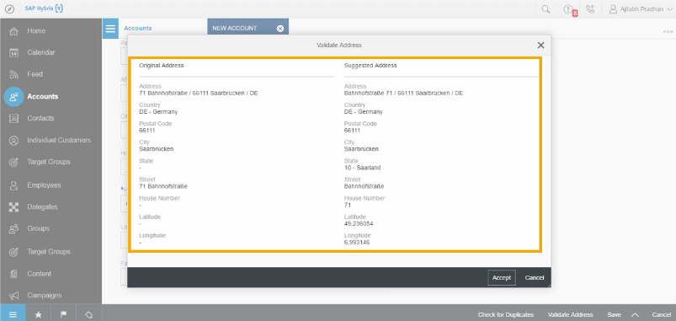
Figure 6 – Address Validation from DQM
Address plausibility (or validity) checks are automatically activated with the connection to DQM, which checks whether the address components satisfy certain rules and are valid. DQM is updated on a quarterly basis, so new premises may not pass the validation. The mass address update can be scheduled as needed. There are standard reports provided by DQM when automating address cleansing within SAP.
  - Provide reports to display addresses for review prior to updating address
  - Provide report to display address errors generated during the adjustment period
If the entered address does not meet the plausibility checks, as shown in Figure 6, the user can proceed without accepting the recommended DQM address.
We will determine our process to update addresses in the system based on the information for DQM in the functional specification.
Duplicate BP Check
DQM is also able to perform business partner duplication check. As seen in Figure 7, when clicking the button, Show Duplicate, if any, there will be list of similar business partners for further consideration. It is recommended to add the e-mail address, Phone and Mobile Phone number as these are methods of communication that the Person BP will retain and should be considered when validating a duplicate BP. A BPEM Case can be manually created to perform further analysis if a user determines that there are two BP’s which are possibly duplicate. (APSE Action #63).
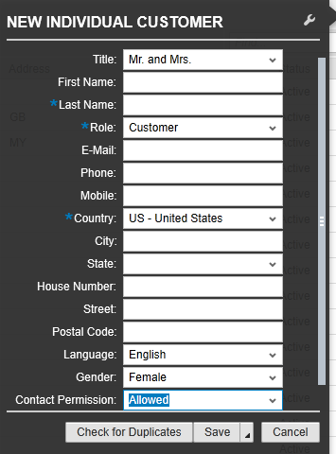
Figure 7 – Business Partner Duplicate Check
Communication Information
The last additional to this section, the communication information such as Telephone, Mobile, E-Mail can be stored in addition to the addresses a BP already has. This can be called as address independent. The communication information can also be used as part of customer preferences for SCE to send any relevant notification a customer has signed up for. The following indicator SMS-Enabled can be used when a device can receive text message. Additional indicator Do not use is normally used as an indicator that this communication number is not be used rather than deleting the number. However this number is still recognized to support inbound/outbound communication even though it may no longer be used temporarily.
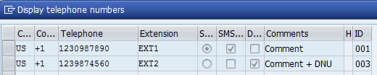
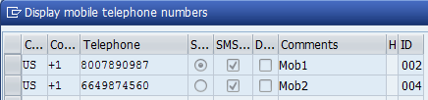
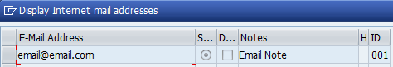
Figure 7a – Communication Information

Identification Numbers
In most cases, at least one of three personal identification types may be requested to set up a BP. The user will attempt to collect and enter the Social Security Number, Drivers’ License or Tax Identification number.
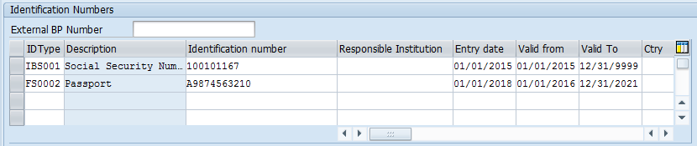
Figure 8a – Identification Numbers in S4HANA

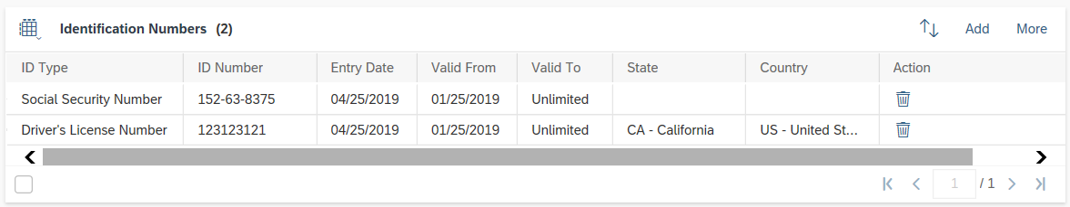
Figure 8b – Identification Numbers in C4C

Furthermore, it also holds the following sensitive information that will be secured with access available to only those needing the information to perform their job (E-CIM-CS-01 - Masking Data for ID Type):
- Banking information (a display of last 4-digit account number will be applied to unauthorized users)
- Personal identification such as Social Security Number (SSN) and Driver’s License number (DLN). Only authorized users would have access to the complete SSN number. All users will have visibility to the last four digits of the SSN.

SAP Standard Offers the following BP ID Types:
ID Cat. | Description | BP Category - Person | BP Category - Organization | BP Category - Group | SCE Use  Y / M
BKK100 | Creditor Identification Number
BUP001 | Dunn & Bradstreet Number |  | X |  | Y
BUP002 | Commercial Register Number
BUP003 | Register of Associations Number
BUP004 | Public Register of Cooperatives Number
BUP005 | Global Location Number
BUP006 | Standard Carrier Alpha Code
BUWMNR | Securities Message Number
COFA | Coface
CPID01 | Counterparty number
CREDS | Creditsafe
CRRF | Creditreform
ELLI | Ellisphere
FS0001 | Identity Card | X
FS0002 | Passport | X |  |  | Y
FS0006 | SWIFT-BIC (Business Identifier Code) |  | X | X
FS0007 | Legal Entity Identifier (LEI)
HCM001 | Personnel Number | X
HCM028 | Internal Personnel Number
HCM030 | Personnel Number (Service Provider)
HCM031 | Personnel Number (Freelance)
IBS001 | Social Security Number | X |  |  | Y
IBS002 | Driver's license number | X |  |  | Y
IBS003 | Registered Charity Number
KSV | KSV Credit Protection Association
PSGBPN
SLLCID | Customs Office Number
SLLEOR | EORI Number
TECH1
TM0001 | Airline Code
TM0002 | IATA SITA/ARINC Scheme |  | X
TM0003 | IATA PIMA Scheme
VATRU | VAT Registration number

BP Person:
SCE has identified the following BP ID Types for BP Person. Encryption in S/4HANA is only available at the file system and redo log level. There is also an option to encrypt backup files. This data will be masked in Hybris C4C.
- Bad Actor / Red List (e.g. safety issue for field personnel)
- Critical Care / Sensitive
- SR Citizen Occupant
- Hearing Impaired
- Cash ONLY
- Driver’s License Number (DLN) and Driver’s License Issuing State
- Tax Identification Number (TIN)
- Social Insurance Number
- Passport #
- State ID Number – (Similar to DLN but for NON drivers)
- Small Business with start/end dates
- Micro Business with start/end dates
- California State Licensing Board (CSLB) License Number
- Bankruptcy (refer to BPD CC-FI-05 - Manage Collections (Dunning) - Manage Bankruptcy, Deceased and Probates) with start/end dates
- Probate (refer to BPD CC-FI-05 - Manage Collections (Dunning) - Manage Bankruptcy, Deceased and Probates with start/end dates
- Same Party In (SPI)

BP Organization or Group:
SCE has identified the following BP ID Types for Organization and Group BP’s. Encryption in S/4HANA is only available at the file system and redo log level. There is also an option to encrypt backup files. This data will be masked in Hybris C4C.
- Tax Identification Number (TIN) (Federal Tax ID)
- Dunn & Bradstreet
- Bankruptcy (refer to BPD CC-FI-05 - Manage Collections (Dunning) - Manage Bankruptcy, Deceased and Probates) with start and end dates
- Probate (refer to BPD CC-FI-05 - Manage Collections (Dunning) - Manage Bankruptcy, Deceased and Probates with start and end dates
- Small Business with start/end dates
- Micro Business with start/end dates
- California State Licensing Board (CSLB) License Number
- Same Party In (SPI)

Payment Transactions
Creation of a Business Partner will have the option to enter certain information, like banking details the user can add, edit, end date or delete the banking details for a BP in Hybris C4C.
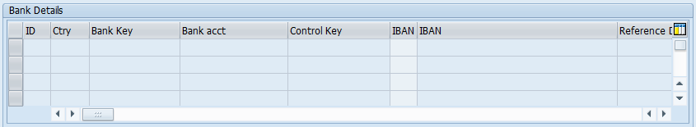
Figure 9a – Business Partner Banking Details in S4HANA

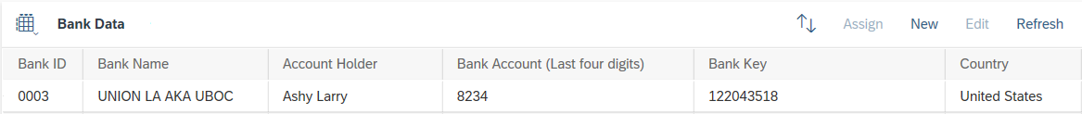
Figure 9b – Business Partner Banking Details in C4C

The Business Partner bank details control which of the Business Partner’s banks is used at the time of payment transaction. The masking of the bank account number will be applied through the enhancement (E-CIM-CS-01 - Masking Data for ID Type) by displaying special characters up to the last four-digit in order to reduce the amount of private information that might be compromised if viewed in a public place. Authorized users will be able to view this data in its entirety to do their jobs. If a Business Partner wishes to no longer use specific bank details, SAP allows the agent to end date or delete the bank details.

Preferences via uPrefer
Preferences or methods of communication regarding utility account, programs and service notifications related to the Business Partner’s accounts, can be managed at several levels, including Business Partner, Contract Account, Contract and Installation. Furthermore, BP and the appointed BP with particular relationship category will also play the role in preferences. A Business Partner may have multiple active emails, mobile numbers (SMS enabled) and landlines, and will be able to select multiple channels for delivery as well as their default preferences for each type of communication. They can also update their preferences by defining a unique preference for programs/services for which they are enrolled or a single preference for all programs/services.
The Business Partner may also opt in (enroll) or out (unenroll) for outbound communication for a specific program, service, campaign or all campaigns.
If a user enters an updated email address, mobile number, or landline number replacing an existing phone or email address, the system will automatically update any communication preferences that were previously created for that device for that BP. The system will also validate the device is capable of supporting that communication preference (e.g., for SMS, the device must be defined as a SMS enabled and if not, alert the user). All changes made to the BP devices and preferences will be logged in change history for future reference and/or investigation.

Below are some of the communication methods that can be used for business partner notifications:
Notification Category | VOICE | TEXT (SMS) | EMAIL
Product & Program Alerts (e.g., Summer Discount, Critical Peak Pricing, Agricultural Pumping Interruptible, Peak Time Rebate DLC, BIP, Budget Assistant, Demand Side Management) | X | X | X
Outage Alerts (one set of preferences for repair, maintenance, rotating and emergency notifications) | X | X | X
Informational/Marketing/Environmental (Ways to Save (includes EE, DR, energy saving tips, summer readiness, Rebates/Incentives, Community Awareness (Philanthropy, Edison Scholars, Safety), Environmental (Examples: EV Awareness, Charge Ready, EV Newsletters), Rate education/information (Examples: You have rate options), Energy Discount Programs) | X | X | X

Business Partner Type
The Business Partner type is a standard field in SAP business partner object that can be used to group several business partners together and/or reporting purpose. At this time, we do not have any data elements that would need to be reported on that are not already included in reporting.

Business Partner Relationship
At SCE, contact customers or those with whom the main BP has a Relationship will be created as a Business Partner and related through these Relationships.
BP relationships are utilized to model relationships between two or more BP’s. In addition to the categorization of the relationship, time restrictions will also be captured. Relationship categories that are utilized can be different between the ‘Person’ BP and ‘Organization’ BP categories. While the relationship between person BP’s will typically define how these BP’s directly relate to each other, such as spouses, parent / minor or roommates, the relationships between a person and an organization define the contact person for that organization, such as an office manager or account manager.

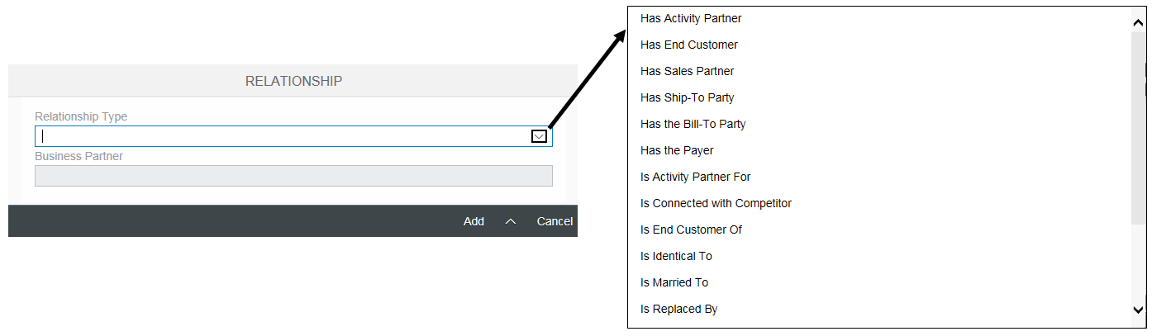
Figure 10 – Partner Contact (Business Partner Relationship)

Once created, it will appear in the Relationship facet as shown in the screenshot below. All Organization Business Partners should have a MAIN contact identified. This needs to be converted from Legacy CRM.
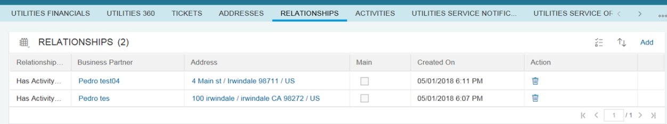

In addition to this standard functionality, with Business Partner Relationship Contact Person, the additional fields such as Function and Department as drop-down field for further maintaining additional information and this is configurable. Currently this functionality is only visible in S/4HANA. Hybris C4C users would have access S/4HANA via an FOP to see this information.
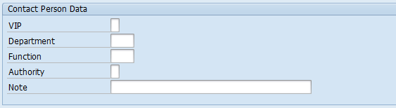
Figure 11 – Business Partner Relationship Contact Person

Below are some of the list of pre-defined SCE relationships:
Relationship Category/Type | BP1 - Person | BP1 - Org | BP1 - Group | BP2 - Person | BP2 - Org | BP2 - Group | Existing/New | Conversion Needed
Authorized Person | X | X | X | X | X | X | Existing | BP Notes
Spouse/Partner | X |  |  | X |  |  |  | BP Notes
Roommate | X |  |  | X |  |  |  | BP Notes
Contact Person | X | X | X | X | X | X | Existing | LCRM-General Customer Contact  LCRM- If BP has relationship=Contact Person
Contact Person Added Facilities | X | X | X | X | X | X | Existing | LCRM-Added Facilities Cust Cont
Contact Person Cust Sat | X | X | X | X | X | X | Existing | LCRM-Cust Sat Customer Contact
Contact Person Outage | X | X | X | X | X | X | Existing | NCRM-  Outage Contact Person  CSS- Contact Type-SACT-MBL outage  LCRM-Planned Outage Cust Cont
Contact Person Essential Use | X | X | X | X | X | X | Existing | LCRM-EssentialUse Cust Contact
Contact Person Cooling Station | X | X | X | X | X | X | Existing | LCRM-Cooling Station Cust Cont
Contact Person Rate&Cust Communications | X | X | X | X | X | X | Existing | LCRM-Rate&Cust Communications
Contact Person Emergency Response | X | X | X | X | X | X | Existing | LCRM-Emergency ResponseContact
Contact Person Facility Contact | X | X | X | X | X | X | New | Maybe

SAP Standard Relationships:
Relationship Cat | Description | BP1 - Person | BP1 - Organization | BP1 - Group | BP2 - Person | BP2 - Organization | BP2 - Group | SCE to Use? Y / M
BBP002 | Invoicing Party Rel. | X | X |  |  | X
BUR001 | Has Contact Person | X | X | X | X |  |  | Y
BUR002 | Has Activity Partner | X | X | X | X | X | X
BUR003 | Has Shared Living Arrangement Member |  |  | X | X
BUR004 | Is Married To | X |  |  | X
BUR006 | Is Identical To | X | X | X | X | X | X
BUR010 | Has the Employee |  | X |  | X
BUR011 | Has the Employee Responsible | X | X | X | X
BUR013 | Is Replaced By | X | X | X | X | X | X
BUR020 | Has Department |  | X |  |  | X
BUR021 | Has Child | X |  |  | X
BUR022 | Is Guardian | X |  |  | X
BUR023 | Is Related To | X |  |  | X
BUR024 | Has Partner in Marriage Partnership |  |  | X | X
BUR998 | Test: Partner <-> Partner | X | X | X | X | X | X
BURC01 | Shareholder Relationship | X | X | X |  | X
CRMH04 | Bill-To Party Relship | X | X | X | X | X | X
EWM001 | Dock App. Sched. Planner |  | X |  | X
FS0030 | Borrower Entity Member | X | X | X | X | X | X
FSB001 | Privat Co. with partners | X | X | X |  | X
FSB002 | Parent company/subsidiary |  | X |  |  | X
HEA010 | Hospital Employee |  | X |  | X
HEA020 | Hospital Employee |  | X |  | X
IHS001 | Medical Address |  | X |  | X | X
LM0001 | Processor Relationship |  |  | X | X
LM0002 | Group Responsibility Rel. |  |  | X | X
LM0003 | Executing Subgroup |  |  | X |  |  | X
SCM001 | SNC Partner User |  | X |  | X
TM0001 | Sales Representative |  | X |  |  | X
UDM001 | Collections Relationship | X | X | X | X
UKM001 | CM Account Hierarchy | X | X | X | X | X | X
UKMSB0 | CM Processor | X |  | X | X | X | X
UKMSBG | Credit Analyst Group |  |  | X | X | X | X

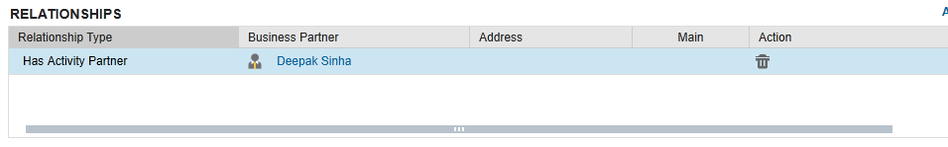
Figure 12 – Business Partner Relationship

Business Partner Hierarchy
A business partner hierarchy is a group of business partners linked to each other through a parent-child relationship. Currently it’s possible to create a hierarchy of accounts only. Hence the term "business partner hierarchy" is used interchangeably with "account hierarchy". The hierarchy is used to link the organizational structure of large customers with multiple levels of subsidiaries and define financial responsibility.
An account hierarchy can be created or changed by an authorized user by using one of the following two ways:
In Customer -> Accounts view, for the account which has to be added to a hierarchy, click on account link to open its details. Navigate to "Account Hierarchy" facet. This facet displays a hierarchy of all child accounts for a child/parent account or top parent account. To add the account to a hierarchy, specify the child parent or top parent account for it. This links the given account to the hierarchy. Navigate to "Account Hierarchy" tab of the parent account and the added account can be seen as a child. Authorization for this process is for RSO Credit and BCD Ops (Territory Management group) to maintain.
An account can have only one top parent in hierarchy, however there can be many child parents. Hence an account is part of only one hierarchy in system. If no top parent is specified for an account, then it implies that the account is either not part of any hierarchy, or it is standalone Business Partner.
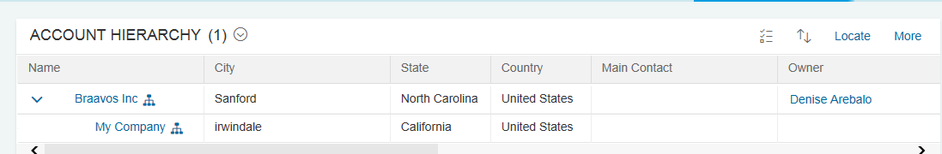
Figure 13 – Business Partner Hierarchy

Business Partner Creditworthiness
Every adverse activity against a BP (e.g. late payment, disconnection for non-payment, bankruptcy) will also have an impact on the overall creditworthiness of the BP. The creditworthiness of a BP is determined by the sum of all events that occur on all Contract Accounts for the BP. Therefore regardless of the number of Contract Accounts maintained for the BP, the creditworthiness score will impact all Contract Accounts.

Each creditworthiness activity has a point value associated with it that will differ based on the type of activity. Therefore more points will be assessed, for example, to a write off than would be assessed to a late payment charge. Each activity will also have an expiration associated with it, so the overall score will improve over time if no more adverse activity occurs. While a returned check activity could expire after one year from the creation of that activity, a bankruptcy activity would typically expire seven years after the creation of that activity. These activities and the associated point values are also detailed further in the BPD CC-FI-21 – Manage Credit – Credit Score.

Business Partner Synchronization
Business Partner Synchronization is the process of creating and maintaining a duplicate copy of a specific data record on a different server. This is accomplished by the intelligent copying of parts of the source database that have changed since the last replication to the destination database. In the case of a BP, the synchronization will occur whenever a data record is created or changed and this synchronization between Hybris C4C and S/4HANA is facilitated via the PI/PO functionality. Any change to an attribute in either system will also reflect in the other system in real-time.
For the implementation at SCE, the system of record for BP data will be Hybris C4C. This means that the primary method of creating or changing BP records will be done via Hybris C4C and this creation or changing of the BP record will replicate into S/4HANA. However, the implementation will also utilize two-way synchronization, which will allow for BP records to be created and / or updated in S/4HANA as business needs dictate and those record changes will likewise synchronize into Hybris C4C in real-time. The creation or changing of BP records in S/4HANA will be limited to a select user group who typically don’t have (or need) access to Hybris C4C.
If synchronization fails, the system will attempt to re-sync or an error will be logged for the (new team) to resolve.

Industry (NAICS) Code
The North American Industry Classification System or NAICS is used by business and government to classify business establishments according to type of economic activity (process of production) in the United States of America. This gets translated to as an Industry code.

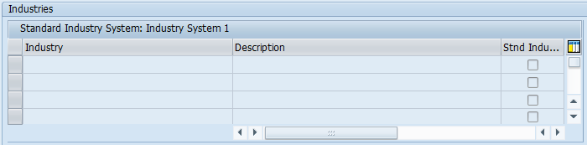
Figure 14 –Industry (NAICS) Code

BP Mass Maintenance (BP and Relationships)
Should there be a need to add, update, and/or end date relationships or BP information for multiple BP’s at the same time, this can be achieved through mass maintenance via either spreadsheets or templates.
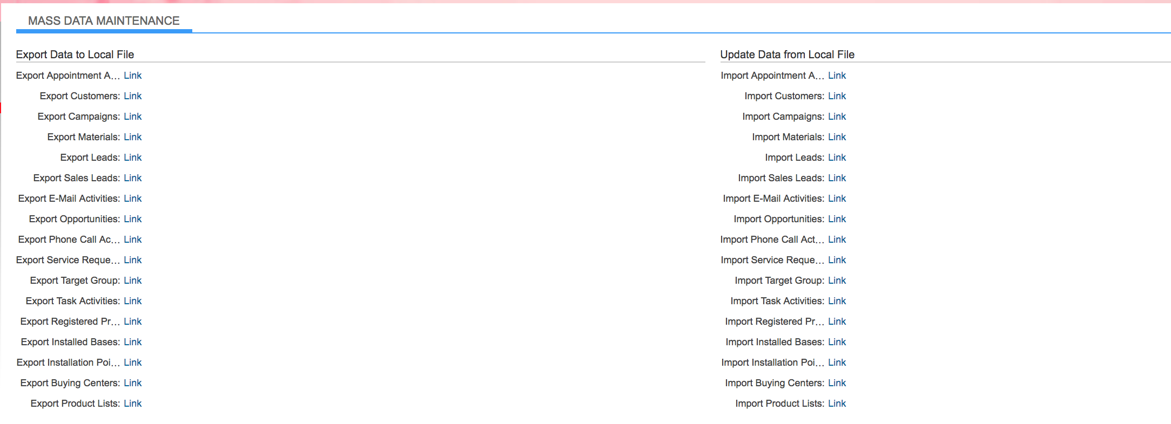

Figure 15 – Mass Data Maintenance

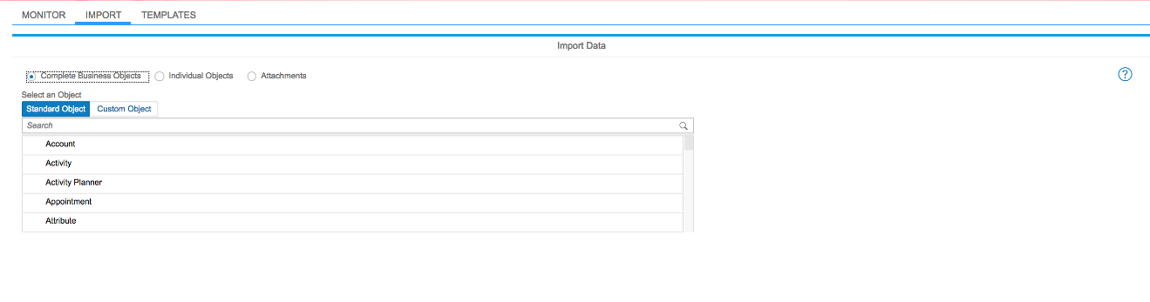
Figure 16 – Mass Data Maintenance with Templates

Marketing Attribute
Marketing Attribute is standard SAP view shown as one of the facets in Hybris C4C. This is used as additional information and normally assigned at BP level. Several attributes can be configured and they are grouped together as Attribute Set for marketing related purpose.
Segment ID’s will be address further in Manage Customer Segmentation & Campaign Management - CIM-CS-15 and Manage Leads, Opportunities & Territory - CIM-CS 16. All Organization BP’s MUST have an identified segment (S1; S2; S4; HB; WG; TP; EC). Person BP will NOT have a Business Partner Segmentation Type identified.
- S1 – Strategic Partner – Face to Face – Assigned to an Account Manager
- S2 – Optimized Service – Mid Market - Targeted Outreach – Assigned to an Inside Account Manager
- S4 – Self Service – If the Organization BP is not assigned to one of the other segments, this is the default.
- HB – Home Builder – Modeled after Strategic Partner (S1)
- WG – Wholesale Generator – Modeled after Strategic Partner (S1)
- TP** – Trade Professional – Modeled after Strategic Partner (S1)
  - ** Can also be assigned as S1, S2, S4
- EC – ESP or CCA – Modeled after Strategic Partner (S1)

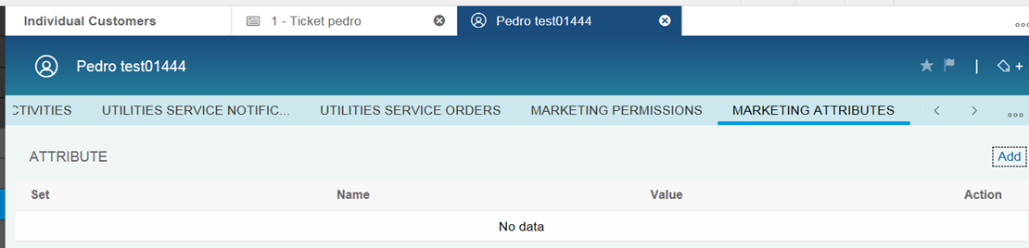
Figure 17 – Marketing Attribute

Integration with Customer Self Service
At SCE, there will be integration with Online Services. While this integration is discussed at length within the BPD CIM-CS-10 Self-Service document, the following functions from within Online Services that directly impact the BP are:
- Change the email address for an existing BP
- Create/update/delete telephone numbers for an existing BP
- Create/update/delete Bank account information
- Create/update customer’s preferences

Integration with Customer Self Service Telephony Process
At SCE, there will be integration with the existing IVR system via SAP Telephony Integration (CTI). While this integration is discussed at length within the BPD CIM-CS-13 Manage Inbound Telephone Call-IVR document, the following functions from within IVR that directly impact the BP are:
- Create/update/delete the telephone numbers/type for an existing BP
- Create/update/delete Bank account information
- Create/update customer’s preferences (maybe)

BP Number Ranges
BP Creation from C4C
When creating a new BP from C4C, the SAP will use the internal number range configured in C4C. Once saved, BP 1200000000 is created, for example. The replication will be triggered to S/4HANA and the external number range will be used to create the same BP number created in C4C earlier. Therefore BP 1200000000 now exists in both systems.

BP Creation from S/4HANA
When creating a new BP from S/4HANA, the SAP will use the internal number range configured in S/4HANA. Once saved, BP 1000000000 is created, for example. The replication will be triggered to C4C and the external number range will be used to create the same BP number created in S/4HANA earlier. Therefore BP 1000000000 now exists in both systems.

Number Range / System | Start Number | End Number
Internal / S/4HANA | 1000000000 | 1199999999
External / S/4HANA | 1200000000 | 1999999999
Internal / Hybris C4C | 1200000000 | 1999999999
External / Hybris C4C | 1000000000 | 1199999999

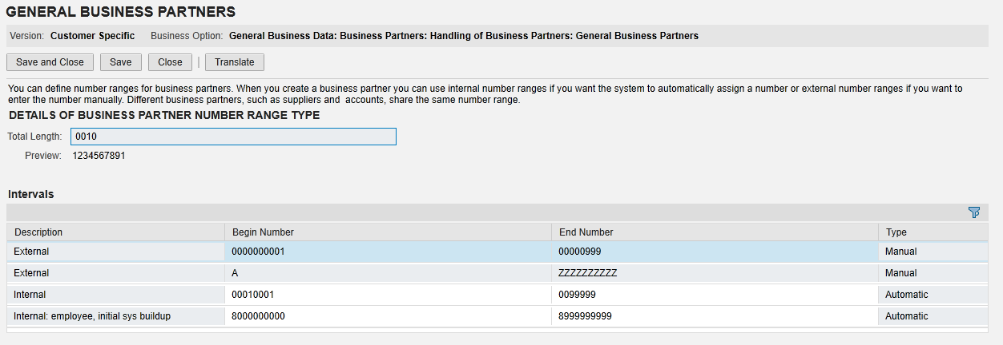
Figure 17 – Hybris C4C Business Partner Number Ranges

For migration purposes, the converted BP data will first be loaded into the S/4HANA BP data tables where it will be assigned its unique identifier from the internal NR from S/4HANA. Therefore the internal NR of S/4HANA will be large enough to accommodate the converted data plus a percentage of additional records that will need to be created during the cutover process and a (limited) projected usage in the creation of BPs in S/4HANA. As Hybris C4C is the system of record for the creation of BPs post go-live, the internal NR of Hybris C4C will be large enough to accommodate all projected future growth for BPs.
Legacy numbers (CU / CA/ SA / ISVC/ Site) will be converted to SAP to cross reference the new internal / External NR with the former legacy account numbers. These numbers are for reference only and are not able to be modified in the SAP system. The user should be able to use these legacy account numbers to search for the BP / Contract Account / Contract.
Legacy CRM Contact BP ID’s – will be converted to SAP to cross reference CRM contacts. These numbers are for reference only and are not able to be modified in the SAP system. The user should be able to use these legacy BP ID’s to search for Contacts.

Process / Performance Improvement
- Provides a centralized store of customer data
- Provides real-time data synchronization
- Enables a broader view of the customer as all transactions for a Business Partner will be housed in one centralized system.
- DQM Validation of mailing addresses

Prerequisites and Inputs
A request to create or change a BP may originate via the following channels or systems:
- Phone call to SCE employee
- IVR
- SCE.com
- U.S. Mail (e.g. Owner Allocation)
- Email
- SMS
- TTY
- Web
- In Person visit

General Assumptions
- Duplicate Business Partners may still exist. The expectation is we will need to minimize the risk of recreating the duplication BPs by performing clean-up before migration.
- Active CU’s will be converted to SAP as the appropriate Person or Organization BP.
- No Group Business Partners will be converted from Legacy systems as they do not currently exist.
- SCE Employee data from SAP-HCM will be integrated as Standard SAP.
- DQM automatic address cleansing process will be determined during the Functional Specification Design.
- Business Partners will need to be “merged” when companies buy and sell businesses.
- Changes to Business Partner Hierarchy’s will continue to need to be updated when companies add additional subsidiaries; merge; or sell off businesses.
- Additional relationships may be identified related to the CISR process within the PP-CS-06 Manage Vendor – Third Party Interfaces

Business Process Hierarchy
This Business Process Hierarchy provides a listing of all scenarios/business processes, sub-processes, and SAP Transaction codes identified to support this process.

Level 1 | Level 2 | Level 3 | Level 4
CCC/BCD/RSO | Business Partner | Create Business Partner | Front Office/C4C System
CCC/BCD/RSO | Business Partner | Change Business Partner | Front Office/C4C System
CCC/BCD/RSO | Business Partner | Display Business Partner | Front Office/C4C System

Process Flows
This BPD will cover two processes, including BP Creation and BP Relationships. Each subsection where the process is detailed will have a process flow diagram for that process and a table detailing the steps that are taken within that process including processes handled outside of SAP.

Business Partner Identification, Creation, BP maintenance
This process flow is for an agent to create a Business Partner in the system.

Process Flow Diagram

Process Flow Steps

Step | Description of Step | Front Office / T-Code | Role(s)
10 | Start | N/A | N/A
20 | Customer Makes Call | N/A | Customer
30 | Call Routed to Agent | N/A | IVR
40 | Agent Accepts Call | N/A | Master Data Processing: CCC/BCD/RSO
50 | Is Customer Identified?  Decision point – was customer verified through IVR? If yes, go to Step 70. If no, go to Step 60. | C4C | Master Data Processing: CCC/BCD
60 | Identify Customer | C4C | Master Data Processing: CCC/BCD
70 | Update Customer Details?  Decision point – does any of the customer’s info (mailing address, phone, email, etc.) need to be updated? If yes, go to Step 80. If no, go to Step 110. | C4C | Master Data Processing: CCC/BCD
80 | Update Customer Details  Go to Step 110 | C4C | Master Data Processing: CCC/BCD
90 | New Customer  Decision point – is this a new customer? If yes, go to Step 100 to create the Business Partner. If no, go to Step 70. | N/A | Master Data Processing: CCC/BCD
100 | Create New Business Partner  Control Point – Agent can bypass the duplicate check and create the Business Partner | C4C | Master Data Processing: CCC/BCD
110 | Create Activity  Agent creates an Activity to log interaction with customer. At this point, the BP will be replicated to S/4HANA. | C4C | Master Data Processing: CCC/BCD
120 | Replication Error?  Decision point – are there any replication errors? If yes, go to Step 130. If no, go to Step 140. | N/A | N/A
130 | Replication Error Resolution  Control Point – An agent will need to attend to and resolve the replication error | PO | Replication Team
140 | Data Replicated to S/4HANA | N/A | N/A
150 | End  The process comes to an end. | N/A | N/A

Business Partner Relationship
Whenever a BP contacts SCE to establish a relationship between themselves and another BP, the Agent will utilize Front Office to make the requested changes.

Process Flow Diagram

Process Flow Steps

Step | Description of Step | Front Office / T-Code | Role(s)
10 | Start | N/A | N/A
20 | Customer Makes Call | N/A | Customer
30 | Call Routed to Agent | N/A | IVR
40 | Agent Accepts Call | N/A | Master Data Processing: CCC/BCD/RSO
50 | Is Customer Identified?  Decision point – was customer verified through IVR? If yes, go to Step 60. If no, go to Step 80. | C4C | Master Data Processing: CCC/BCD/RSO
60 | Create/Change Partner Contact  Establish relationship between customer and another BP. | C4C | Master Data Processing: CCC/BCD/RSO
80 | Identify Customer | C4C | Master Data Processing: CCC/BCD/RSO
90 | New Customer?  Decision point – is this a new customer? If yes, go to Step 100 to create the Business Partner. If not, go to Step 60. | C4C | Master Data Processing: CCC/BCD/RSO
100 | Create New Business Partner  Control Point - Agent can bypass the duplicate check and create the Business Partner | C4C | Master Data Processing: CCC/BCD/RSO
105 | Create Activity  Agent creates an Activity to log interaction with customer. At this point, the BP will be replicated to S/4HANA. | C4C | Master Data Processing: CCC/BCD/RSO
110 | Replication Error?  Decision point – are there any replication errors? If yes, go to Step 120 for resolution. If no, go to Step 130. | N/A | N/A
120 | Replication Error Resolution  Control Point – An agent will need to attend to and resolve the replication error | PO | Replication Team
130 | Data Replicated to S/4HANA | N/A | N/A
140 | End  The process comes to an end. | N/A | N/A

3rd Party and SCE Legacy System Integrations

3rd Party or SCE Legacy System Integration | Description of Integration and Required Change to 3rd Party or SCE Legacy System | Estimated Complexity of 3rd Party or SCE Legacy system change
Genesis – IVR
SCE.com
Torres Credit Services &  ER Solutions (Collection Agency) | TBD if applicable to BP | TBD if applicable to BP
FirstCall | TBD if applicable to BP | TBD if applicable to BP
GridX | TBD if applicable to BP | TBD if applicable to BP
iEnergy | TBD if applicable to BP | TBD if applicable to BP
Oasis | TBD if applicable to BP | TBD if applicable to BP
AESC | TBD if applicable to BP | TBD if applicable to BP
Design Manager | TBD if applicable to BP | TBD if applicable to BP
Marketing | TBD if applicable to BP | TBD if applicable to BP
Dunn and Bradstreet /SAPCND/GCM | TBD if applicable to BP | TBD if applicable to BP
Convergent | TBD if applicable to BP | TBD if applicable to BP
Gas/Water Utilities | TBD if applicable to BP | TBD if applicable to BP
CCA | TBD if applicable to BP | TBD if applicable to BP
State Of California (Payments) | TBD if applicable to BP | TBD if applicable to BP
WAPA | TBD if applicable to BP | TBD if applicable to BP
MDMA | TBD if applicable to BP | TBD if applicable to BP
NMIS | TBD if applicable to BP | TBD if applicable to BP
HEES | TBD if applicable to BP | TBD if applicable to BP
Greyhair | TBD if applicable to BP | TBD if applicable to BP

Data Elements
The information that will be captured for the BP (either as part of migration or in the course of normal processing) will be defined as being specific to a single BP category or applicable to all categories. Likewise, information captured for BPs may also be linked to a specific type of role.

All Categories
The following data elements will be used by the BPs, regardless of the category to which the BP has been assigned.

Source Systems and Data Volumes
Source:
- CSS (general data, contacts, address, name, ID Numbers)
- LCRM (Assigned non-residential customer contacts, BP Contact Person, Roles, Relationships/preferences, Marketing Attributes; general data; mailing address; name; ID Numbers )
- NCRM (residential and small business outage contact information and preference for outage)
- ENS (CPP and Budget Assistance contact information and preferences for alerts)
- ONC (rotating outage contact information and preferences)
- Revenue Protection
- Account Management (sub-system of CSS)
- RPI IDS (part of revenue protection)

Data Volume: Approximately 37,000,000

Cloud for Customer (C4C) Integration

Processes
Business Partner set up can be done in Hybris C4C and is available for Front Office agents to perform the task. Refer to BPD CIM-CS-17 – Front Office for detailed processes.

C4C Views
Standard screen is made available in Hybris C4C where a new BP can be created.
Standard screen in brief made available in the BPD CIM-CS-17 – Front Office where a new BP can be created.
The Standard Hybris C4C Business Partner view used in searching for a BP, as seen in Figure 18 & 19, provides the common data elements necessary for locating a BP.
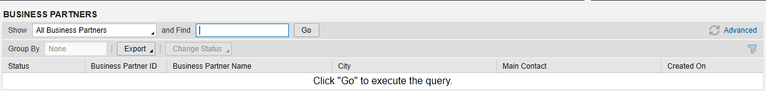
Figure 18 – Business Partner Basic Search
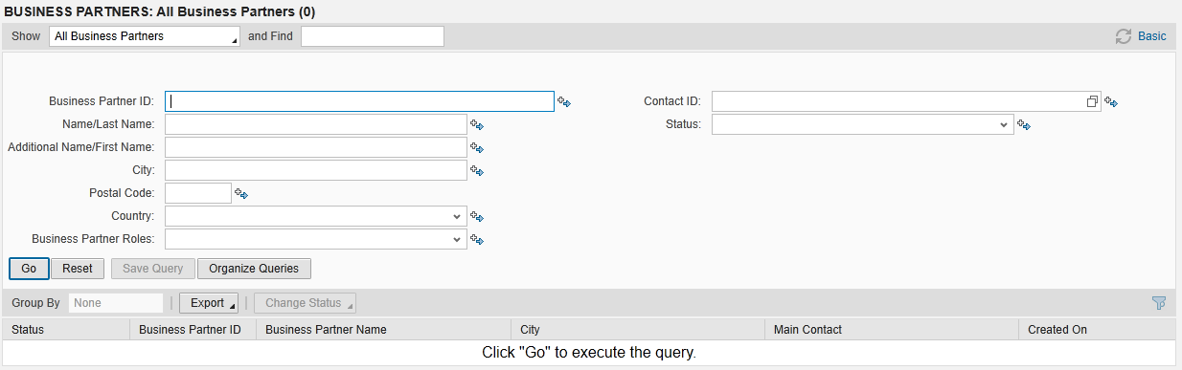
Figure 19 – Business Partner Advance Search

BP Create – Person
The Standard Hybris C4C Create Individual Customer view in creating a Person, as seen in Figure 20, provides the common data elements necessary for creating a BP who has been identified as a ‘Person’.
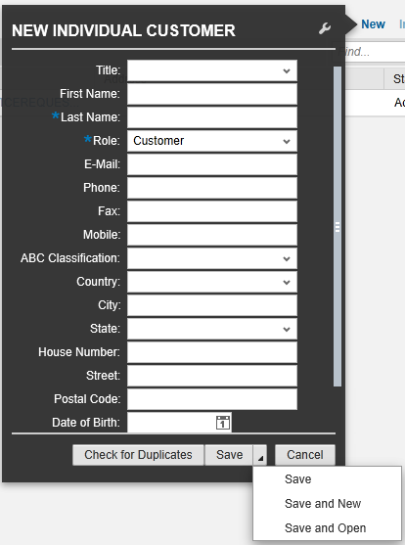
Figure 20 – Create BP (Person)

BP Create – Organization
The Standard Hybris C4C create Account view in creating a BP Organization, as seen in Figure 21, provides the common data elements necessary for creating a BP who has been identified as an ‘Organization’.
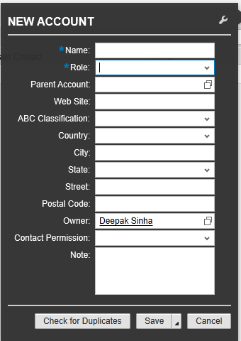
Figure 21 – Create BP (Organization)

Activity
A new Activity can be created after the Business Partner has been newly created or changed in the system.

C4C FOP to S/4HANA
If a C4C user needs to complete an action or view information that is only available in S/4HANA, the user will be able to use the ‘Launch FOP’ button that will link to specific transaction in S/4HANA. When the user has a BP or account loaded (any account level) in C4C and clicks on the FOP button, a particular transaction from S/4HANA will be triggered for the user to perform further actions. For example when the user launches the FOP for “Change Banking Information”, the Business Partner screen from S/4HANA will be shown in edit mode and the user will need to navigate to the tab “Payment Transactions” to perform necessary banking information changes.

Exception Management Requirements
This section outlines a high level description of each BPEM Case or other user workflow items (such as “Tickets” used by Front Office) used to route work requests between business areas. The companion document for this section which outlines the detail of each case is documented in APSE on the Exception Case Template General Document #8.
User Exception Scenario / Description | User Group | Initiated by | Work Distribution
See attached document below

Process Risks and Mitigation
- Duplicate Business Partners may exist, due to human error. This can lead to confusion as to which Master Data to use. The duplicate BP check will be utilized to mitigate this risk.
- Organization business partners may be incorrecly converted as Person Business partners as they are set up incorrectly in the legacy source system. Mitigation 1: is to use the RATE as a key to identification of the BP Type. Clean-up in the source system is not possible. Mitigation 2: Manually create the Organization BP correctly Post migration
- Person Business Partners may be incorrectly converted as Organization Business partners as they are set up incorrectly in the legacy source system. Mitigation 1: is to use the RATE as a key to identification of the BP Type. Clean-up in the source system is not possible. Mitigation 2: Manually create the Person BP correctly Post migration.
- Business Partner synchronization errors are required to be resolved in a timely manner, otherwise subsequent transactions cannot be performed. Mitigation: New team to resolve synchronization errors same day as failure and communicate to users for awareness and provide ETA.
- Mailing address is a required field. This will impact how web Ids are created today and if the BP is converted with the correct mailing address or correct BP type (Prospect etc.)

Key Performance Indicators
The following have been identified as KPI’s at Southern California Edison, along with the means of measuring each KPI and the current measurement statistic for each KPI:
Measured KPI | Description | Measurement Method | Current Statistic

Key Metric Definition
The following have been identified as key metrics at Southern California Edison that require business rule for calculation:
Key Metric | Description | Business Rule | Reference
N/A | N/A | N/A | N/A

Controls, Regulatory Rules, and Security
Requirement  ID (from RTM) | “As-Is” Control Requirement | “To Be” Risk Statement | “To-Be” Control Activity” | Control Automation (manual, IT dependent- manual, automated, SOD, Sensitive Access) | Relevant technical identifier or RICEFW reference
New | NA | Inaccurate or incomplete business master data may lead to bad debt increases or evenue loss. (If Business Partner (BP) synchronization error is NOT resolved in a timely manner, subsequent transactions for the BP cannot be performed.) | Users from Replication team have to manually execute transaction in S/4 HANA whenever there is replication error while creating BP in C4C. This will ensure any synchronization error while creating BP gets resolved in timely manner. (Step 130) | ITDM | N/A
New | NA | Inaccurate or incomplete business master data may lead to bad debt increases or evenue loss. (If Business Partner (BP) synchronization error is NOT resolved in a timely manner, subsequent transactions for the BP cannot be performed.) | The replication team is to monitor the replication frequently via SAP HCI in order to ensure the error-free replication. The replication team will determine whether there is a need to have collaboration effort with the business to resolve the replication error in timely manner. (Step 130) | ITDM | N/A
CONTROL-CS-1205 | Use Preferred Modes of Communication For Medical Baseline Customers (DisabRA Settlement Agreement): SCE is required to continue to use preferred alternative modes of communication identified by Medical Baseline (MBL) customers to provide emergency notifications. (See DisabRA Settlement Agreement, IV.B.2.a). | Noncompliance or misinterpretation with regulatory and legislative requirements may lead to misstatement of financial statements, penalties, fines and/or prosecution from governing regulatory bodies. (If Preferences for the MBL and DisabRA customers which will be taken care by Enhancement E-CIM-CS-01 Manage Preferences is not available, then customer preferences would not be identified for outreach or be communicated to.) | When a Business Partner account is created, modified or validated, the customer service representative manually checks the Medical Baseline (MBL) status and communication preferences settings to ensure communication preferences (email, text, phone, emergency contact, etc.) are accurately recorded for the customer in SAP ISU. (Step 100) | ITDM | E-CIM-CS-01  Enhancement will enable the BP preferences to be captured
CONTROL-CS-1207 | Collect Preferred Modes of Contact From Medical Baseline (MBL) Customers & Contact Based on Alternative Mode (DisabRA Settlement Agreement): SCE is required to continue to gather information from Medical Baseline (MBL) customers to determine their preferred means of contact in emergency circumstances, and contact customers based on the preferred alternative mode of contact. The capabilities of using alternative modes of contact and the range of notification will be expanded by SCE's proposed Alerts and Notification system. (See DisabRA Settlement Agreement, IV.B.2.b). | Noncompliance or misinterpretation with regulatory and legislative requirements may lead to misstatement of financial statements, penalties, fines and/or prosecution from governing regulatory bodies. (If Preferences for the MBL & DisabRA customers which will be taken care by Enhancement E-CIM-CS-01 Manage Preferences is not available, then customer preferences would not be identified for outreach or be communicated to) | When a Business Partner account is created, modified or validated, the customer service representative manually checks the Medical Baseline (MBL) status and communication preferences settings to ensure communication preferences (email, text, phone, emergency contact, etc.) are accurately recorded for the customer in SAP ISU. (Step 100) | ITDM | CIM-CS-01-R0307
CONTROL-CS-1214 | Electronic Alerts and Notices for Customers with Vision Disabilities (DisabRA Settlement Agreement): SCE is required to use reasonable efforts to provide electronic alerts and notices in accessible formats to customers known to have Vision Disabilities. (See DisabRA Settlement Agreement, IV.E.1). | Noncompliance or misinterpretation with regulatory and legislative requirements may lead to misstatement of financial statements, penalties, fines and/or prosecution from governing regulatory bodies. (If Preferences for the DisabRA customers which will be taken care by Enhancement E-CIM-CS-01 Manage Preferences is not available, then customer preferences would not be identified for outreach or be communicated to) | When a Business Partner account is created, modified or validated, the customer service representative manually checks to determine preferences for electronic alerts are provided in the correct accessible format for customers known to have Vision Disabilities. (Step 100) | Manual | E-CIM-CS-01
CONTROL-CS-2216 | Implement High Usage Alert System for CARE Customers: SCE shall continue implementation of a high usage alert system for California Alternate Rates for Energy (CARE) Program High Usage Customers in a month utilizing SCE’s upgraded My Energy/My Account systems and smartphone apps as well as through traditional outreach methods. Costs associated with these notification directives should be accounted for in SCE’s Rate Reform memorandum accounts (OP 83). SCE is directed to ask CARE customers by which means they would like to receive such notifications, and to notify customers by the usual means of communication if the customer does not choose a notification method. To reduce “messaging fatigue” and reduce costs, these high usage notifications shall be combined with SCE’s Home Energy Reports (HERs) as a single mailer/e-mail for those selected HERs customers (pg. 292).  (See OP 83 and pg. 292 of D.16-11-022). | Noncompliance or misinterpretation with regulatory and legislative requirements may lead to misstatement of financial statements, penalties, fines and/or prosecution from governing regulatory bodies. (If Preferences for the CARE customers which will be taken care by Enhancement E-CIM-CS-01 Manage Preferences is not available, then customer preferences would not be identified for outreach or be communicated to) | On a “insert how often the report gets distributed“ basis SCE will send out high usage alert notifications for CARE customers based on the customer’s communication preferences recorded in the Business Partner account. If no preferred method of notification is documented SCE will manually as the CARE customers how hig usage alert notifications should be communicated to them. (Step 100) | Manual | E-CIM-CS-01
CONTROL-CS-2242 | Deliver Rate Education Report per Customer Preference: SCE shall deliver Rate Education Reports via e-mail or direct mail, dependent upon a customer’s communication preference or other justification. These mailers shall be combined with SCE’s Home Energy Reports (HER) as a single mailer/e mail for those customers already participating in the HER program.  (See OP 106 and pgs. 323-324 of D.16-11-022). | Noncompliance or misinterpretation with regulatory and legislative requirements may lead to misstatement of financial statements, penalties, fines and/or prosecution from governing regulatory bodies. (If Preferences for the HER customers which will be taken care by Enhancement E-CIM-CS-01 Manage Preferences is not available, then customer preferences would not be identified for outreach or be communicated to) | SCE will generate the “Deliver Rate Education Report“ and distribute to the customer on a (TBD: insert how often the report gets distributed) basis based on the customer’s communication preferences recorded in the Business Partner account. (Step 100) | ITDM | E-CIM-CS-01
CONTROL-CS-1188  (Transferred from DF-DM-02) | Accommodate Customer Communication Preferences for Alerts and Notifications (DisabRA Settlement Agreement): SCE agrees to continue to accommodate customer communication preferences for alerts and notifications under the Disability Rights Advocates’ Settlement. SCE shall use reasonable efforts to provide electronic alters and notices in accessible formats and final disconnection notices by phone to customers who are known to have Vision Disabilities and to accommodate customer communication preferences through its Alerts and Notifications Project. In the event that alerts or notifications covered by the Alerts and Notifications Project are provided in a written email format, SCE shall use reasonable efforts to cause the telephone number and a TTY number for further inquiries, if any, to be displayed in a larger font size. Other than as described above, this does not apply to customers notices regarding risk of service disconnection, which is being separately addressed in R.10-02-005. [D.12-11-051, p. 688]. (See also DisabRA Settlement Agreement, Appendix A, Section IV.E.1). | Noncompliance or misinterpretation with regulatory and legislative requirements may lead to misstatement of financial statements, penalties, fines and/or prosecution from governing regulatory bodies. | When a Business Partner account is created, modified or validated, the customer service representative will manually check to determine preferences for electronic alerts are provided in the correct accessible format for customers known to have Vision Disabilities. (Step 100) | ITDM | E-CIM-CS-01
CONTROL-SOX-3279 (Consolidated with CONTROL-SOX-3281 &  3263,  transferr  ed from  UB-BI-09,  for DQM  address  validation & also  consolida  ted with  CONTROL  -SOX-  3277 &  3278  transferr  ed from  CC-FI-01 )  ) | Bills are not sent to correct customers (fraud) - in the legacy system addressed via: 1.7 - Control C1 - Account setup validations are performed within the CCC system on data input into its respective fields. [Consolidated with (1) "Bills are not produced and/or received by customers - in the legacy system addressed via 1/6 - Control C4 – Validated Mailing Addresses in CSS. (2) Bills are not sent to correct customers (fraud) - in the legacy system addressed via: 1.7 - Control A1 - CSS assigns a unique identity for each customer in CSS' five customer relationship levels and (3) Bills are not produced and/or received by customers - in the legacy system addressed via: 1.7 - Control A1 - CSS assigns a unique identity for each customer in CSS' five customer relationship levels] | Inappropriate generation or distribution of customer invoices may lead to uncollected revenues or customer dissatisfaction. (Bills are not sent to correct customers - fraud) | Business partner account validation is performed within the DQM system based on the specific data inputs (Street number, Street, City, State & Postal code) from SAP ISU . (Step 100) | ITDM | NA
CONTROL-CS-1190 Remove from scope – this relates to SCE reaching out to MBL customers to inform them of alternatives when there is an unplanned power outage and is not a system requirement. | Outreach to Special Customer Classes Regarding Emergency Notifications and Alternatives/Support During Unplanned Outages (DisabRA Settlement Agreement): SCE agrees to continue to conduct outreach to Medical Baseline (MBL) customers to inform them of alternatives and support available should an unplanned outage occur. (See DisabRA Settlement Agreement, IV.B.2.a; See also D.12-11-051, p. 688).  Standard system has check for duplic Outreach to Special Customer Classes Regarding Emergency Notifications and Alternatives/Support During Unplanned Outages (DisabRA Settlement Agreement): SCE agrees to continue to conduct outreach to Medical Baseline (MBL) customers to inform them of alternatives and support available should an unplanned outage occur. (See DisabRA Settlement Agreement, IV.B.2.a; See also D.12-11-051, p. 688). | Noncompliance or misinterpretation with regulatory and legislative requirements may lead to misstatement of financial statements, penalties, fines and/or prosecution from governing regulatory bodies (  If Preferences for the MBL & DisabRA customers which will be taken care by Enhancement E-CIM-CS-01 Manage Preferences is not available, then customer preferences would not be identified for outreach or be communicated to.) | When the BP is created, modified or validated, the CSR will check the MLB status and communications preferences (e-mail, text, phone, etc...) for the BP in the SAP IS-U. | N/A | -CIM-CS-01 Enhancement will enable the BP preferences to be captured

Requirement ID  (from RTM) | Requirement Description | Requirement Type (Business Rule, Control Audit, Legal/Regulatory) | Additional Details  (e.g. SoX, COSO, CPUC, FERC, NERC)
3279 | Bills are not sent to correct customers (fraud) - in the legacy system addressed via: 1.7 - Control C1 - Account setup valida tions are performed within the CCC system on data input into its respective fields. | Control Audit | SOX
1190 | Outreach to Special Customer Classes Regarding Emergency Notifications and Alternatives/Support During Unplanned Outages (DisabRA Settlement Agreement): SCE agrees to continue to conduct outreach to Medical Baseline (MBL) / Critical Care customers to inform them of alternatives and support available should an unplanned outage occur. (See DisabRA Settlement Agreement, IV.B.2.a; See also D.12-11-051, p. 688). | Legal/Regulatory | CPUC
1205 | Use Preferred Modes of Communication For Medical Baseline Customers (DisabRA Settlement Agreement): SCE is required to continue to use preferred alternative modes of communication identified by Medical Baseline (MBL) / Critical Care customers to provide emergency notifications. (See DisabRA Settlement Agreement, IV.B.2.a). | Legal/Regulatory | CPUC
1207 | Collect Preferred Modes of Contact From Medical Baseline (MBL) Customers & Contact Based on Alternative Mode (DisabRA Settlement Agreement): SCE is required to continue to gather information from Medical Baseline (MBL) /customers to determine their preferred means of contact in emergency circumstances, and contact customers based on the preferred alternative mode of contact. The capabilities of using alternative modes of contact and the range of notification will be expanded by SCE's proposed Alerts and Notification system. (See DisabRA Settlement Agreement, IV.B.2.b). | Legal/Regulatory | CPUC
1214 | Electronic Alerts and Notices for Customers with Vision Disabilities (DisabRA Settlement Agreement): SCE is required to use reasonable efforts to provide electronic alerts and notices in accessible formats to customers known to have Vision Disabilities. (See DisabRA Settlement Agreement, IV.E.1). | Legal/Regulatory | CPUC
2216 | Implement High Usage Alert System for CARE Customers: SCE shall continue implementation of a high usage alert system for California Alternate Rates for Energy (CARE) Program High Usage Customers in a month utilizing SCE’s upgraded My Energy/My Account systems and smartphone apps as well as through traditional outreach methods. Costs associated with these notification directives should be accounted for in SCE’s Rate Reform memorandum accounts (OP 83). SCE is directed to ask CARE customers by which means they would like to receive such notifications, and to notify customers by the usual means of communication if the customer does not choose a notification method. To reduce “messaging fatigue” and reduce costs, these high usage notifications shall be combined with SCE’s Home Energy Reports (HERs) as a single mailer/e-mail for those selected HERs customers (pg. 292).  (See OP 83 and pg. 292 of D.16-11-022). | Legal/Regulatory | CPUC
2242 | Deliver Rate Education Report per Customer Preference: SCE shall deliver Rate Education Reports via e-mail or direct mail, dependent upon a customer’s communication preference or other justification. These mailers shall be combined with SCE’s Home Energy Reports (HER) as a single mailer/e mail for those customers already participating in the HER program.  (See OP 106 and pgs. 323-324 of D.16-11-022). | Legal/Regulatory | CPUC

Security Considerations
Role | Transaction Code (T-Code) | T-Code Description | Authorization Attributes | SOD Conflicts (Yes/No)  If SOD Conflicts Yes. Identify the 2 conflicting t-codes
Master Data Processing: CCC/BCD/RSO | C4C (Workcenter: Call Center) | Create Business Partner | Create
Master Data Processing: CCC/BCD/RSO | C4C (Workcenter: Call Center) | Change Business Partner | Change
Master Data Processing: CCC/BCD/RSO | C4C (Workcenter: Call Center) | Display Business Partner | Display
Master Data Processing: CCC/BCD/RSO | FPP1 | Create Business Partner | Create
Master Data Processing: CCC/BCD/RSO | FPP2 | Change Business Partner | Change
Master Data Processing: CCC/BCD/RSO | FPP3 | Display Business Partner | Display
Master Data Processing: CCC/BCD/RSO | BP | Create Business Partner  Change Business Partner  Display Business Partner | Create  Change  Display
Hierarchy Maintenance: BCD Ops, RSO Credit (all RSO CAPS except for Payment team) | C4C (Workcenter: Call Center) | Create Business Partner Hierarchy | Create
Hierarchy Maintenance: BCD Ops, RSO Credit (all RSO CAPS except for Payment team) | C4C (Workcenter: Call Center) | Change Business Partner Hierarchy | Change
Hierarchy Maintenance: CCC, BCD, BCD Ops, RSO Credit (all RSO CAPS except for Payment team) | C4C (Workcenter: Call Center) | Display Business Partner Hierarchy | Display

Custom Program/Transaction Codes
Please identify any custom programs/transaction codes that need to be developed for RICEFW objects.
- Is the custom program executed in the batch mode or dialogue mode
- Is the custom program assigned to an authorization group
- What is the custom transaction code for the custom program
- Should there be an authorization check made against any field in the custom program/custom t-code and if so what is the custom/standard authorization object used(For example does it have to be restricted to residential vs commercial customer)
- Does the custom programs/custom t-codes have any crictial or sensitive customer information that needs extra security
Custom Program | Authorization Grp | Custom T-code | Authorization Object used in the authorization check statement

Custom Table/Transaction Codes
Please identify any custom tables/transaction codes that need to be developed for RICEFW objects.
- Are there any customer sensitive/critical Z tables created
- What is the authorization group assigned to the table
- Is it just a maintenance or display only table
- What is the Z transaction code for the custom table

Custom Table | Authorization Grp Assigned | Custom T-code for the Table | Table Access (display/update)

Data Criticality and Cybersecurity Baseline Risks
Specify Data Classification /Special Handling or Regulatory Requirement  What is the classification of Data? Does it trigger any special regulations?  Please select the classification / Sensitivity of the Data. This will help us Assess the Risk associated and remediation measures if any. | <Select all that apply>  ☒ PII - Personal Identifiable Information / Privacy Law  ☐ CEII - Critical Energy Infrastructure Information  ☐ FERC SOC (Standards of Conduct)  ☐ NERC CIP Confidential  ☐ Sarbanes-Oxley (SOX) financial reporting data  ☐ SCE utility data accessible by affiliate companies (CPUC)  ☐ PCI - Payment Card Industry Compliance  ☐ Customer Information Service Request (CISR, CISR-DRP)  ☐ Other _<Please Specify>_  ☒ Internal  ☐ Public  ☒ Confidential
Please identify which business Group/Role will require access to the data and/or solution:  Please select the list of Busines Groups will have access to this Data / Process. This will help us Determine the Impact and Risk Spread. Will ensure efficient Risk mitigation measures. | <Select all that apply>  ☐ SCE Customer, Res./Comm. Customer;  ☐ SCE OU, Business Function Organization Name:  ☐ Vendor  ☐ External business partner(s) & SaaS providers  ☒ External on-shore contractors  ☒ External off-shore contractors  ☒ SCE Affiliate Company Employees  ☐ SCE Employees, specify if they have Marketing Function responsibilities (e.g., ES&M)  ☒ SCE contract workers  ☐ Regulatory Agencies  ☐ Others _<Please Specify>_
How many of the SCE Customer, Employee, Vendors will use or affected by the Business Process?  To identify the Impact if services are adversely affected. | 10,000+…..
How much Information/data would be processed, received or tramitted by the Business Process?  The data volume that will be utilized by this process. Helps us in determining the Impact and criticality | 100 MB / GB  100 - 1,000 MB / GB  1,000 - 10,000 MB / GB  10,000+ MB / GB…..
Number of business transactions in average?
These are the number of transactions process by the application on average. The number of transactions help in understanding criticality and Impact.
Additional Security Consideration: | Any Cybersecurity impact in addition to SAP system security:  - Internet Facing Web Application? Yes/No, Details: Yes on SCE.COM  - Internet Facing Application Programming Interface? Yes  - 3rd party Fedrated Authentication & Authorization, Single Sign On? Yes

Technical Considerations

4.1 RICEF-W Assessment
All of the Forms, Reports, Interfaces, Conversion items, Extensions/Enhancements and Workflows (RICEF-W) that have been identified for this BPD are detailed in the tables below and will represent the totality of all RICEF-W items documented at the time of sign-off of this BPD. Any RICEF-W items that are confirmed via change control after this BPD receives final sign-off, will be managed within Southern California Edison’s APSE environment and not within this document.

Reports
Report Name & Description (List Requirements met by this Report) | Complexity | Reference ID
BCD Report - Essential use & outage completeness |  | 7744 - REP-CIM-CS-01-0007 BP Communication Report

Interfaces
Interface Name & Description (List Requirements met by this Interface) | Complexity | Reference ID

Conversion
Conversion Name & Description (List Requirements met by this Conversion) | Complexity | Reference ID
- Convert all active BP Contact Persons from LCRM for business customers to ISU including all person contact info and person details (e.g., mailing address, phone, email, role, tax classification, etc). Note: A clean-up will be done before migration  - Convert all active Main BP Contact Person indicators from the LCRM CU Contact Assignment Block for business customers to ISU. Note: A clean-up will be done before migration  - Covert all Spouse and Roommate information from CSS Customer level to ISU as an Activity (note) on the associated BP  Convert all active BP Contact Persons from NCRM for ISU including all person contact info and person details. Note: A clean-up will be done before migration | Complex | C-CIM-CS-01 – PARTNER
- Convert all active BP Org/Person/Contact Person relationships from LCRM to ISU including all relationships (CU and SA level) and alert preference details. Note: A clean-up will be done before migration and alignment with to-be relationships types.
- Convert all Business Customer attributes and IDs from LCRM to ISU when the Customer has an active Customer Account.
- Convert all active Prospects from LCRM to ISU and all attributes (e.g., contact info, roles, etc.)
- Covert all active primary and secondary phone numbers and phone types, language preference and special needs (e.g., braille bill, large font bill, etc.) for residential and unassigned business accounts from CSS customer level to ISU. Note: A clean-up will be done before migration because currently ~50% of the numbers are not active.
- Convert all Customers from CSS to ISU that have at least one active Customer Account including all profiles/attributes.
- Convert all active/pending Customer Accounts from CSS to ISU including mailing address and all appropriate profiles/attributes.
- Convert all active/pending Service Accounts from CSS to ISU including all appropriate profiles/attributes.
- Convert all active Third Party authorizations (e.g., CISR, Rule 24, other) and authorization details from all source systems (e.g., CSS, SCE.com, Access DB) all levels (CU, CA, SA) into ISU as relationships to the BP or other level as appropriate.
- Covert all active BP Org/Person/Contact Person relationships from NCRM to ISU including all relationships (CU level) and outage alert preference details. Note: A clean-up will be done before migration and alignment with to-be relationships types.  - Covert all active MBL Contacts, contact details, relationships (Service Account/Contact) and Outage alert preferences from CSS to ISU. Note: A clean-up will be done before migration and alignment with to-be relationships types.  - Covert all active Budget Assistant Contacts, contact details, relationships (Service Account/Contact) and alert preferences from CSS/ENS to ISU only when these systems are the source systems. Note: A clean-up will be done before migration and alignment with to-be relationships types.  - Covert all active CPP Contacts, contact details, relationships (Service Account/Contact) and alert preferences from CSS/ENS to ISU only when these systems are the source systems. Note: A clean-up will be done before migration and alignment with to-be relationships types.  - Covert all active ONC Contacts, contact details, relationships (Service Account/Contact) and alert preferences from ONC to ISU only when ONC is the source system. Note: A clean-up will be done before migration and alignment with to-be relationships types  Covert all active SCE.com Contacts, contact details, relationships (contact/customer/customer account/service account) and alert preferences from SCE.com to ISU only when SCE.com is the source system. Note: A clean-up will be done before migration and alignment with to-be relationships types | Complex | C-CIM-CS-01 - PAR_REL  C-CIM-CS-01 - Comm Pref
Covert all active customer hierarchy relationships from CSS to ISU. Note: A clean-up will be done before migration and alignment with to-be relationships types. | Medium | C-CIM-CS-01 - Corporate Hierarchy

Extension/Enhancements
Extension Name & Description (List Requirements met by this Extension) | Complexity | Reference ID
Ability for the system to automatically remove the minor indicator when the person BP turns 18 years old. | Medium | E-CIM-CS-01 - BPIDEnhancement
The system shall allow the user to only enter numeric values and format the PER number for a BP person. | Medium | E-CIM-CS-01 - PersonnelValidation
After a user saves a BP person PER number, the system shall mask the view of the number and only display the last four digits to the user. | Medium | E-CIM-CS-01 - PersonnelMasking
After a user saves a BP person social security number, the system shall mask the view of the number and only display the last four digits to the user.  - After a user saves a BP person driver's license number, the system shall mask the view of the number and only display the last XXX digits to the user.  - The system shall mask the view of the BP banking information after it is saved by the user. | Medium | E-CIM-CS-01 - Masking Data for ID Type
After a user saves a BP person social security number, the system shall mask the view of the number and only display the last four digits to the user.  - After a user saves a BP person driver's license number, the system shall mask the view of the number and only display the last XXX digits to the user. | Medium | E-CIM-CS-01 - ID Type Masking for C4C
- Ability for the system to automatically add/update a customer profile that meet the small business criteria on an annual basis from at BP level  - Ability for the system to automatically remove customer(s) that no longer meet the small business criteria on an annual basis at BP level | Medium | E-CIM-CS-01 - BPUpdate
- Ability to search for relationships / preferences that are due for review and validation  - Ability to search by relationship category, name, phone, email and other attributes | Medium | E-CIM-CS-01 – BPRelationshipSearch
System should default the relationships / preferences to active and provide users the ability to select all to see end-dated as well as active ones | Medium | E-CIM-CS-01 – BPRelationshipValidity
If a user changes the phone type from mobile to landline for a BP in their contact devices and if the phone is enrolled in SMS notifications, the system shall display an error message to the user. | Medium | E-CIM-CS-01 - No of Comm Method limitation
The system enable a BP to have a max number of active mobile numbers, landlines and email addresses at the same time. The max for each type shall be configurable. | Medium | E-CIM-CS-01 - No of Comm Method limitation
- The system shall allow a user to log the consent from the customer for use of outbound communications via mobile phone. (TCPA Compliance)  - Ability to capture a person BP's consent for SCE to utilize a BP's Mobile phone for marketing purposes (TCPA rule)  - Ability to capture a person BP's consent for SCE to utilize a BP's email address for marketing purposes (CAN/SPAM rule)  - The system shall enable a user to define a Business Partner's default preference for Account Notifications (e.g., payment processed, enrollment confirmation, final call notification, move-out confirmation, etc).  - The system shall enable a user to define a Business Partner's default preference for Informational/Marketing communications (e.g., Ways to Save, Environmental, etc.).  - The system shall enable a user to define a Business Partner's default preference for Outage communications (e.g., repair, maintenance, emergency, macro, etc.)  - The system shall enable a user to define a Business Partner's default preference for Informational/Marketing communications (e.g., Ways to Save, Environmental, etc.).  - The system shall enable a user to define a Business Partner's default preference for Outage communications (e.g., repair, maintenance, emergency, macro, etc.).  - The system shall allow a user to log the consent from the customer for use of outbound communications via mobile phone. (TCPA Compliance)  - If the system automatically un-enrolls the device from notifications, an Account Manager should be notified.  - The system shall enable a user to define a Business Partner's default preference for Account Notifications (e.g., payment processed, enrollment confirmation, final call notification, move-out confirmation, etc). | Complex | E-CIM-CS-01 – ManagePreference
- Ability for the system to restrict the entry of a Land line extension where the extension is Not allowed for notification purposes based on business rules  - The system shall require BP to have relationship with another BP which authorizes them to enroll in alert/notifications for the BP  - Ability for the authorized user to update customer or contact preferences  - The system shall enable a user to update a BPs preference for a particular notification type (i.e. outage alert preference for the outage they reported)  - The system shall enable the user to define unique communication preferences for programs/services the BP is enrolled in or a single preference for all programs/services  - Ability for the user to manage preferences at Business Partner level (i.e. Customer, Contact)  - Ability for the user to manage preferences at Contract Account level  - Ability for the user to manage preferences at Contract level  - Ability for the user to manage preferences at Installation level  - User shall be able to select multiple contact delivery channels for each notification  - System shall have the ability to allow multiple contact delivery channels for each notification  - If a user updates a mobile number for a BP in their contact devices to a different number, then the system shall apply the number update where ever the previous mobile number was enrolled in notifications (SMS, Voice and/or TTY).  - If a user updates a landline phone number for a BP in their contact devices to a different number, then the system shall apply the number update where ever the previous landline phone number was enrolled in notifications (Voice and/or TTY).  - If a user updates an email address for a BP in their contact devices to a different email address, then the system shall apply the email address update where ever the previous email address was enrolled in notifications.  - The system shall enable a user to set up a BP to be enrolled in SMS, Voice, Email and/or TTY, Social Media notifications for a program/service notifications at the BP level (meaning notifications are sent for all applicable accounts associated to the BP).  - The system shall enable a user to set up a BP to be enrolled in SMS, Voice, Email and/or TTY, Social Media notifications for a program/service notifications at the Contract Account level (meaning notifications are sent for all applicable accounts associated to the Contract Account).  - Ability to create a relationship between the Business Partner and the Contract/Installation  - Ability for the System to create Relationships (or preference) a Person Business Partner to receive specific notifications such as outage; Power Bulletin, Demand response etc. and have this relationship linked to the Organization or Group at the appropriate "level Contract Account or Contract | Complex | E-CIM-CS-01 – ManagePreference
- Ability to create Relationships (or preference) for an Organization or Group at the appropriate "level Contract Account or Contract Business Partner to receive specific notifications such as outage; Power Bulletin, Demand response etc. and have this relationship linked to the Person Business Partner  - Ability to see which Contract Account(s) the Organization or Group Business partner is linked to  - Ability to see which Contract(s) the Organization or Group Business partner is linked to  - Ability to see which TMD the Organization or Group Business partner is linked to  - Ability to link from a Person; Organization; or Group Business partner to the Contract Account/Contract relationships  - Ability to view the Contract Relationships (or preference) from the Organization, or Group , or Business Partner  - Ability for the system to complete the relationship modification to the corresponding relationship when the update is made on the Person; Organization or Group Business partner. based on business rules (e.g.. Person Business Partner Relationship is updated - system automatically makes the same update to the Corresponding Organization or Group Business partner or the Organization / Group Business Partner Relationship is updated - system automatically makes the same update to the corresponding Person Business partner.)  - - Ability for the user to opt in an authorized customer contact for an outbound communication for a specific program, service, campaign or all campaigns (if eligible).  - Ability for users to opt-out/in a customer from marketing material  - Ability for an authorized user to add, edit, and remove preference categories (i.e. Outage, Account, Marketing) without impacting historical data.  - Ability to display Contract Account, Contract and Premise preferences linked to BP  - Ability to provide a message to the user when the communication method is left blank for a relationship / preference.  - Ability for the system to create a BPEM case when the communication method is left blank for a contact relationship / preference assigned to the appropriate account manager  - Ability for the system to apply precedence to utilize contract level relationship data first (where available), then utilize Business Partner level relationship data for marketing campaigns  - The system shall enable a user to set up a BP to be enrolled in SMS, Voice, Email and/or TTY, Social Media notifications for a program/service notifications at the Installation level.  - The system shall enable a user to set up a BP to be enrolled in SMS, Voice, Email and/or TTY, Social Media notifications for a program/service notifications at the BP, Contract Account and Contract level at the same time for same notification type.  BCD: Added Social Media to the list | Complex | E-CIM-CS-01 – ManagePreference
- The system shall enable a user to set up a BP to be enrolled in SMS, Voice, Email, Social Media, and/or TTY, notifications for a program/service notifications at the BP, Contract Account and Contract level at the same time for different notification types.  - The system shall enable a user to set up a BP to have one or more mobile numbers enrolled in SMS notifications for the same account(s) and notification type at the same time.  - The system shall enable a user to set up a BP to have one or more mobile numbers enrolled in SMS notifications for the same account(s) and different notification types at the same time.  - The system shall enable a user to set up a BP to have one or more mobile numbers enrolled in SMS notifications for the different account(s) and the same notification type at the same time.  - The system shall enable a user to set up a BP to have one or more one mobile numbers enrolled in SMS notifications for the different account(s) and different notification types at the same time.  - The system shall enable a user to set up a BP to have one or more mobile numbers enrolled in Voice notifications for the same account(s) and notification type at the same time.  - The system shall enable a user to set up a BP to have one or more mobile numbers enrolled in Voice notifications for the same account(s) and different notification types at the same time.  - The system shall enable a user to set up a BP to have one or more mobile numbers enrolled in Voice notifications for the different account(s) and the same notification type at the same time.  - The system shall enable a user to set up a BP to have one or more mobile numbers enrolled in Voice notifications for the different account(s) and different notification types at the same time.  - The system shall enable a user to set up a BP to have one or more landline numbers enrolled in Voice notifications for the same account(s) and notification type at the same time.  - The system shall enable a user to set up a BP to have one or more landline numbers enrolled in Voice notifications for the same account(s) and different notification types at the same time.  - The system shall enable a user to set up a BP to have one or more landline numbers enrolled in Voice notifications for the different account(s) and the same notification type at the same time.  - The system shall enable a user to set up a BP to have one or more email address enrolled in Email notifications for the same account(s) and notification type at the same time.  - The system shall enable a user to set up a BP to have one or more email address enrolled in Email notifications for the same account(s) and different notification types at the same time.  - The system shall enable a user to set up a BP to have one or more email address enrolled in Email notifications for the different account(s) and the same notification type at the same time. | Complex | E-CIM-CS-01 – ManagePreference
- The system shall enable a user to set up a BP to have one or more email address enrolled in Email notifications for the different account(s) and different notification types at the same time.  - The system shall enable a user to set up a BP to have one or more landline/mobile numbers enrolled in TTY notifications for the same account(s) and different notification types at the same time.  - The system shall enable a user to set up a BP to have one or more landline/mobile numbers enrolled in TTY notifications for the different account(s) and the same notification type at the same time.  - The system shall enable a user to set up a BP to have one or more landline/mobile numbers enrolled in TTY notifications for the different account(s) and different notification types at the same time.  - The system shall enable a user to set up a BP to have one or more mailing addresses enrolled in US Mail notifications for the same account(s) and notification type at the same time.  The system shall enable a user to set up a BP to have one or more mailing addresses enrolled in US Mail notifications for the same account(s) and different notification types at the same time.  - The system shall enable a user to set up a BP to have one or more mailing addresses enrolled in US Mail notifications for the different account(s) and the same notification type at the same time.  - The system shall enable a user to set up a BP to have one or more mailing addresses enrolled in US Mail notifications for the different account(s) and different notification types at the same time.  - The system shall enable a user to set up a BP to be enrolled in SMS, Voice, Email and TTY for the same account and same notification type at the same time.  - The system shall enable a user to set up a BP to be enrolled in SMS, Voice, Email and TTY for the same accounts and different notification type at the same time.  - The system shall enable a user to set up a BP to be enrolled in SMS, Voice, Email and TTY for the different accounts and same notification type at the same time.  - The system shall enable a user to set up a BP to be enrolled in SMS, Voice, Email and TTY for the different accounts and different notification type at the same time.  - Ability for the user to opt in an authorized customer contact for an outbound communication for a specific program, service, campaign or all campaigns (if eligible).  - Ability for a user to opt out an authorized BP out of marketing related program (default or previously signed up for)  - System shall enable a user to opt out a communication for a BP if the program allows opt out  - Ability for users to opt-out/in a customer from marketing material | Complex | E-CIM-CS-01 – ManagePreference
- Ability for an authorized user to add, edit, and remove preference categories (ie Outage, Account, Marketing) without impacting historical data.  - If a user makes a mobile number, landline or email address inactive for a BP and the device is enrolled in notifications for that BP, the system shall display a warning message to the user but allow the user to inactivate the number  - If a user updates a mobile number, landline or email address inactive for a BP and the device is enrolled in notifications for that BP, the system shall automatically un-enroll the device from those notifications. | Complex | E-CIM-CS-01 – ManagePreference
- An authorized user shall have the ability to add a note to multiple accounts (in mass) in the system at the BP, Contract Account, Contract or Premise level.  - The system shall enable an authorized user to add the same note content to multiple accounts in mass (e.g., upload a file).  The system shall enable an authorized user to add unique notes for each account in mass (e.g., upload a file). | Medium | E-CIM-CS-01 - BMD Mass Update
System should default the relationships / preferences to active and provide users the ability to select all to see end-dated as well as active ones |  | E-CIM-CS-01 - BP Customer Preference Expiration
 |  | E-CIM-CS-01 - Opt Out correspondence indicator for the customer
Ability for an authorized user to add, edit, and remove rules to avoid over-communication. |  | E-CIM-CS-01 - Over communication Rules
- After a user saves a BP person PER number, the system shall mask the view of the number and only display the last four digits to the user.  Ability for the system to notify the user if a duplicate PER is entered. |  | E-CIM-CS-01 - Personnel Validation
Ability for the system to apply precedence to utilize contract level relationship data first (where available), then utilize Business Partner level relationship data for marketing campaigns |  | E-CIM-CS-01 - Prioritize preferences
Ability to report on changes made to customer preferences |  | R-CIM-CS-01 – Customer preference History Log

Forms
Form Name & Description (List Requirements met by this Form) | Complexity | Reference ID
N/A | N/A | N/A

Workflows
Workflow Name & Description (List Requirements met by this Workflow) | Complexity | Reference ID
N/A | N/A | N/A

IDEX Considerations
- ESP / CCA / DA will be converted need details – These will be covered in the IDEX conversion.

Production System Cut-over Considerations
BP’s to be selected for migration:
- All Active Customers – customers with active customer accounts
- Customers with non-zero balance
- Customers with organizational hierarchy
- Customers who have been set up as 3rd Party suppliers/Demand Response Providers
- Tenant information for master metered accounts (MBL tenants, DMS tenants, etc.)
- SCE employee -may duplicate the BP if the employee has an active SCE account. May only want to migrate employees who do NOT have SCE accounts (1 BP with Multiple Roles vs 2 BP ID’s for same person)
- All Active Prospects

4.4 Other Considerations
N/A

Change Management

5.1 Change Impacts
Change Element Short Description | Change Impact Category | Audience Group(s) | Impact | Business Effort
SAP has different terminology between the Front office and Back office applications. | Process (122) | CS-CSOD-RSO All; CS-CSOD-CCC All; CS-BCD-All | Low | Low
In SAP, all entities that are associated with the sold to party may have multiple BP account relationships which will provide improved visibility of all relationships related to the sold to party. Today most relationships are considered to be contacts (e.g. spouse, employees of company etc.). Account relationships in SAP are linked at the BP level with a description of relationship. Example: the corporation is created as a customer and anyone else associated with the corporation is added as a contact (e.g. President, CEO, CFO, analyst)  Customer impact: Benefit - business partner will have visibility to all account relationships. It can provide more information of other business partners associated with the customer but interaction with front office may be longer as they gather information. | Process; Decision Making (123) | CS-CSOD-CCC All; CS-BCD-All; CS-CSOD-Consumer Affairs;Ext-Customers-All; | High | Medium
Currently customer account numbers are 9 digits in length and begin with the number 2. In SAP, Contract Account numbers will be 12 digits in length and the leading indicator will be a 4, 5, 6 or 7 depending on the account type. An account number beginning with a 4 will be a 3rd Party Supplier account , a 5 will be a stand-alone Deposit account , a 6 will be a Collective account, a 7 will be a will be a Standard or Joint Contract . Users will be able to locate the legacy account number in the BP level. Users will need to advise customers about the new account identifiers and where to locate it on their statement in the event that they call the contact center and use their old CSS account number as a search criteria. External customers will be impacted and can drive call volume. For back office users, it may add additional AHT for account look up in the MDMS and will have an impact to CCA/DA third parties. It may also have reporting impacts.  Account number changes will impact external vendors that will impact their files and mapping.  . | Process; Decision Making (127) | CS-CSOD-CCC All; CS-CSOD-RSO All; CS-BCD All; Ext-Customers-All; Ext-Third Party Vendors-All; Ext-Third Party Vendors-Banks, CP&S – Information Governance. Consumer Affairs | Medium | Medium
In SAP, all mailing addresses associated with the customer are stored and tracked at the BP level with one being used as the standard address. Currently mailing addresses are at the customer account level. In addition, there is a one to one relationship with regards to customer level address. Users will need to be trained to review the BP level for multiple mailing addresses before creating contract accounts. | Process (128) | CS-CSOD-CCC All; CS-BCD-All; CS-CSOD-RSO All  ; CSOD-Consumer Affairs | Low | Low
Mailing address verification process is currently performed by third-party and this will be changed in SAP (Address verification will be done in SAP). Going from 1 month to 4 months. Concern – Increase of return mail. We need to ensure this will not impact the cost savings with USPS and Compliance. May increase operational work to handle increase of return mail and manual clean-up of addresses. | Process; Regulatory/Legal; Technology (132) | CS-CSOD-CCC All; CS-CSOD-RSO All; CS-BCD-All  CP&S – All ; CSOD-Consumer Affairs | CCC/BCD –Medium  RSO - High | CCC/BCD –Low  RSO - High
In SAP, prefix/suffix are included in the street name field. Currently each of these are on separate fields. It will make the searching for addresses simpler since these fields are all included in the street name (e.g. Pacific NW) | Process (228) | CS-CSOD-CCC All; CS-BCD-All;  CP&S – Report and Analytics; CS-CSOD-Consumer Affairs | CCC/BCD Low  CP&S - Medium | CCC/BCD Low  CP&S - Medium
There will be a single contract account for Energy and Deposits for a majority of accounts. Credit and Payment services will have the ability to issue deposits on a separate contract account for large commercial customers as part of the Early Warning process. Currently we have separate customer accounts for energy and deposits. Two separate statements are mailed to the customer with different due dates. Users will need to advise the customer about the deposit details due date along with the first statement. This may cause some issues for our customers that may have problems with paying both the deposit and the energy statement. (Assumption: Agent will have visibility to bill cycle information) | Process; Benefit/Improvement; Culture Shift; Regulatory/Legal (129) | CS-CSOD-CCC All;Ext-Customers-All;CS-BCD-All;CS-CSOD-RSO All;CS-CSOD-Consumer Affairs | Medium | Medium
With SAP, agents will need to collect the phone number and email during customer interactions including when creating the BP. Today, agents always collect a contact phone number but Email is not requested. The information will be available in the future for customer notifications but it will add to average handle time. | Process (215) | CS-CSOD-CCC All; CS-BCD-All. CS- Consumer Affairs | Low | Low
SAP allows for smart search capabilities. It will provide suggestions as the agent types in more data. It can also provide a wildcard search option (using *). It also allows to search by multiple criteria such as name and house number. CSS currently does not have the functionality. The agent has to type the street name, customer name or account number as search options. As a result, searches should be quicker and provide more flexibility. | Process, Benefit/Improvement (208) | CS-CSOD-CCC All; CS-BCD-All; CS-CSOD-RSO All; CS-CSOD-Consumer Affairs | Low | Low
In SAP, the front office provides the ability to add a critical care flag. Currently the critical care profile is associated with the medical baseline process only. The decision will need to be made on whether or not Front Office is allowed to do this. | Job Roles; Process; Benefit/Improvement; Decision Making; Regulatory/Legal (234) | CS-CSOD-CCC All; CS-CSOD-Consumer Affairs | Medium | Medium
In SAP, BP creation will require category, role and type. We currently do not provide this level of detail today but having the information will allow for better marketing strategies in the future. We will require training to ensure that users understand the different types and select the appropriate entry at time of creation or update. BCD currently follows this process but will need to learn new roles, categories and types.  Examples: Role - Sold to Party, Vendor  Category: Person, Organization, Group  Type: Key Account, Trade Associations, Res/Non Res | Process (226) | CS-CSOD-CCC All; CS-CP&S-All; CS-BCD-All; CS-CSOD-Consumer Affairs | CCC –Medium  BCD-Low | CCC – Medium  BCD-Low
In SAP, contracts cannot be moved from one contract account to another which is current functionality. In future, to move contracts, a move in will need to be issued. This will have customer impacts as well possible escalations for scenarios such as Change Name Only - Deceased or for customers that request for summary or solo billed. Service history begins again as well as a new contract and contract account is created. Customer satisfaction will be impacted. This will also impact completing customer merges in the system.  Customer Impact: Customers' will receive new account information because a new contract will need to be created. They will need to look at the previous account to view any historical usage information. | Process (227) | CS-CSOD-CCC All; CS-CSOD-RSO-Credit; Ext-Customers-All; CS-BCD-All; CS-CSOD-Consumer Affairs | High | High
In the future, when customers apply using a paper application for rebates and other programs if SSN and/or Tax ID is listed on the application, they will need to add the information into the BP level. They currently do not enter the data into CSS since they primarily work in different systems. Users will need to be trained to enter the information once they process the application. | Process (231) | CS-CSOD-CCC-PS; CS-CP&S-All; CS-CSOD-Consumer Affairs | Low | Low
Due to legacy data inconsistencies, customer fields such as spouse, roommate, and authorized caller will be converted to a note at the BP level in SAP during conversion. Agents will need to review the notes to determine if they are authorized to call on the accounts. If there is a note and the authorized caller contacts SCE, the user will need to create them as a business partner and build the relationship with the complete information. Average handle time may increase agents will need to review notes to determine if they are authorized as well as create a business partner and relationship to the main BP.  Customer Impact - Customer information will need to be added to create the BP relationships. It will add time to the customers' call. | Process; Decision Making (232) | CS-CSOD-CCC All;CS-BCD-All;CS-CSOD-Consumer Affairs;Ext-Customers-All | CCC –Medium  BCD - Low | CCC-Medium  BCD - Low
In SAP there is a field for Other ID Non Standard that can be used for other forms of identification. This field is not available in CSS today. Users will need to be aware of what the field should be used for so that agents do not use it for other purposes (e.g. passwords, nicknames etc.) to minimize bad data. The field may be deactivated if Credit decides not to uses other forms of ID. | Process (233) | CS-CSOD-CCC All; CS-CSOD-Consumer Affairs | Low | Low
In SAP, users will create a ticket/BPEM to authorized users to merge duplicate BPs. Currently the CCC does not merge duplicate BPs. They have a manual workaround in which an email is sent to a different group to merge customers to ensure accuracy. The ticket/bpem will allow for tracking of the request. The process for merging customers is more complex in SAP. Currently users have the ability to transfer accounts to customers and merge. In the future, authorized users will need to create a move in and move out and transfer any attributes to the new customer. | Process; Job Roles; Decision Making (236) | CS-CSOD-CCC All  CS-BCD-All; CS-CSOD-RSO | High | High
SAP, the North American Industry Classification System (NAICS) code will replace the SIC codes and will be held at the BP and premise level. The BP will have a primary code but premise level can have different codes based on each locations. Currently SCE stores the SIC codes at the Installed and site levels in CSS. | Process; Decision Making (238) | CS-CSOD-CCC All; CS-BCD-All; CS-CSOD-Consumer Affairs | Low | Low
In SAP, users have the ability to add attachments at the customer level. Users can have visibility to marketing items, CISR docs, OTA. CSS does not have the ability today. Users rely on notes, communications or portal (e.g. FETCH) to view attachments. Users will not need to search for the attachments in the future since they will be readily available at the BP level. | Process; Benefit/Improvement (239) | CS-CSOD-CCC All; CS;BCD-All; CS-CSOD-RSO All; CS-CP&S-All; Ext-Customers-All | Medium  CP&S - High | Medium  CP&S - High
SCE will need to revisit the return mail process to determine what to do to update the BP. For instance if the return mail type is a monthly bill, the user will need to contact the customer to update the address. | Process; Benefit/Improvement (242) | CS-CSOD-CCC-All; CS-CSOD-RSO-All  CS-BCD-All, CS CP&S; CS-Consumer Affairs | Low  CP&S - Medium | Low  CP&S - Medium
In SAP, it is recommended to not mix account types (e.g. Residential, Agricultural, Commercial, etc.) when using contract accounts. Users will need to be able to review the contract accounts and select the appropriate account for the customer at the time of turn on. This will require business partners to have multiple contract accounts. When accounts are converted, business partners will need to be notified about the changes to account number. BCD has a higher number of accounts that will be impacted. | Process (243) | CS-CSOD-CCC All; CS-BCD-All; CS-CSOD-RSO ALL | CCC –Medium  BCD - High | CCC-Medium  BCD - High
All transactions/orders must replicate to the backend from the front end tool. If it fails, someone must address the replication error. A new role will be required to address exceptions. SCE business users are more appropriate to work on replication issues as SCE IT may not have the authorized system functionalities to fix the data compared to business users. | Job Roles (35) | CS-CSOD-CCC All; CS-CSOD-RSO All; CS-BCD-All | Low | Low
SAP has a flag that will allow the remittance address to stay the same even though the Business Partner (BP) address has been updated. Today, these addresses are kept separately and no flag has to be set. Conversely if all addresses needs to be changed, they can be. Users will need to be trained when to use the flag so that billing is not interrupted. | Process (39) | CS-CSOD-CCC All; CS-BCD-All | Low | Low
For preference options, the contact data relates back to the Business Partner (BP) contact data (phone, email, mobile, social media etc.). Users will create preferences to provide different customer communications based on channel preference (eg. voice, text, email etc). This is a pending enhancement and the process will be determined based on the solution selected. CSS/CWO currently does not have a preference option and legacy CRM uses relationships for communications. | Decision Making; Culture Shift; Process (466) | CS-BCD-All; CS-CP&S-All; CS-CSOD-CCC All | High | High
Agent will need to discuss the communication delivery types and bring up a discussion regarding what to use the contact type for - detailed discussion regarding notifications/preferences or in the future, drive them to use a self-service option. This is something BCD does currently but is a process change for CCC. | Benefit/Improvement; Decision Making; Culture Shift; Process (465) | CS-CSOD-CCC All  CS-CP&S-CX&I (digital team) | Medium | High
Customers will have the ability to opt in/opt out of preferences for multiple communication categories through different communication channels (e.g. agent, sce.com, IVR) including any black out timeframes which allows customers more flexibility and choices with regards to communications. | Benefit/Improvement; Decision Making; Process (579) | Ext-Customers-All; CS-CSOD-CCC All; CS-BCD-All | CCC – Medium  BCD - Low | CCC – Medium  BCD - Low
Business Customer Division (BCD) will create a link between the BP and the Org BP to send any communications to the customers if it is a single party. For multiple parties, relationships will need to be created between BP's for communications. BCD will need to learn more about the preferences process. | Benefit/Improvement; Process (580) | CS-BCD-All | Low | Low
In SAP, BCD will be creating preferences in place of relationships for programs such as Planned Outages, Customer Satisfaction and DR programs etc. Currently BCD creates relationships for these types of requests in legacy CRM. This will decrease the amount of relationships that BCD will build for the customer. There is a new methodology that needs to be trained to BCD to ensure that customers are receiving their notifications like they do today seamlessly. | Process; Culture Shift (657) | CS-BCD-All | Medium | Medium
Policy discussion regarding the level of access for different relationships and authentication requirements in regards to account activity. As part of the process, the frontline users may require to review relationships with the customer at the time of move in and move out. The relationships may need to be updated based on the conversation. Currently authorized callers can access all information and issue transactions without any differentiation. | Decision Making, Process, Culture Shift (465) | CS-CSOD-CCC All; CS-BCD-All | High | Medium
Employees will not have separate prompts to capture the Requested by info, call disposition or notes. All info will need to be captured in an Activity Record. Risk of Energy Advisors (ENA's) will not capture this information as required during each call | Decision Making, Process (506) | CS-CSOD-CCC All; Consumer Affairs | High | High
All employees will be a business partner in the new system. Currently employees are only in the system if they are the customer sold to party. | Culture Shift (520) | CS-All | Low | Low

Below is a description of each:
Change Element Short Description: Describes the ‘As-Is’ scenario and what is changing.
Change Impact Category: Determined by asking the questions below.
- Staffing Levels - Is the work effort increasing or decreasing (staffing levels), and how (e.g., task automation, new process/tasks)?
- Job Roles - Will the responsibilities, authority, or required skills for a job or job roles change? Will people be reporting to new leaders? Will managers’ responsibilities change?
- Compensation / Performance - Will the changes have such an impact on roles of an individual that merits a change in how they are compensated or how their performance will be evaluated? What behaviors are rewarded and recognized?
- Organization Structure - Is the ownership of the Process or Data changing (think departments, jobs, or roles, not individuals)?
- Decision Making - Will any of the changes impact how decisions are made, by or between, business units / departments? Who makes them, how they determine the criteria for making a change?
- Culture Shift - Will organizational value systems impact the way change happens or be impacted by the change? What are the underlying values of the organization that will directly influence the way change will be accepted and how much work will ultimately be required to ensure successful outcomes for the business?
- Location / Facilities - Will the change impact the physical location where they process is being implemented or require changes to the facilities to enable the process to be effective?
- Process - Any change to the current process (e.g. manual process becomes automatic, or vice versa)? Are there new processes being introduced or an old process being decommissioned? Is there a requirement to change an existing business rule or business policy? Will new business rule or policy needs to be introduced and enforced or complied to?
- Regulatory/ Legal - Are there any legal / regulatory requirements that might be impacted
- Technology - Are other applications impacted (e.g., going away, becoming read-only), or are there new requirements (e.g., new SW / HW, new version)
- Benefit/Improvement - Will there be an improvement or benefit to any of the stakeholders because of this change. (Be sure to include any pain points that are being alleviated)
- Other - Are there emotional implications stemming from any of these changes (think of buy-in issues or fears)
Audience Group(s): These are the affected departments, divisions etc…
Impact: The following were used to determine the impact:

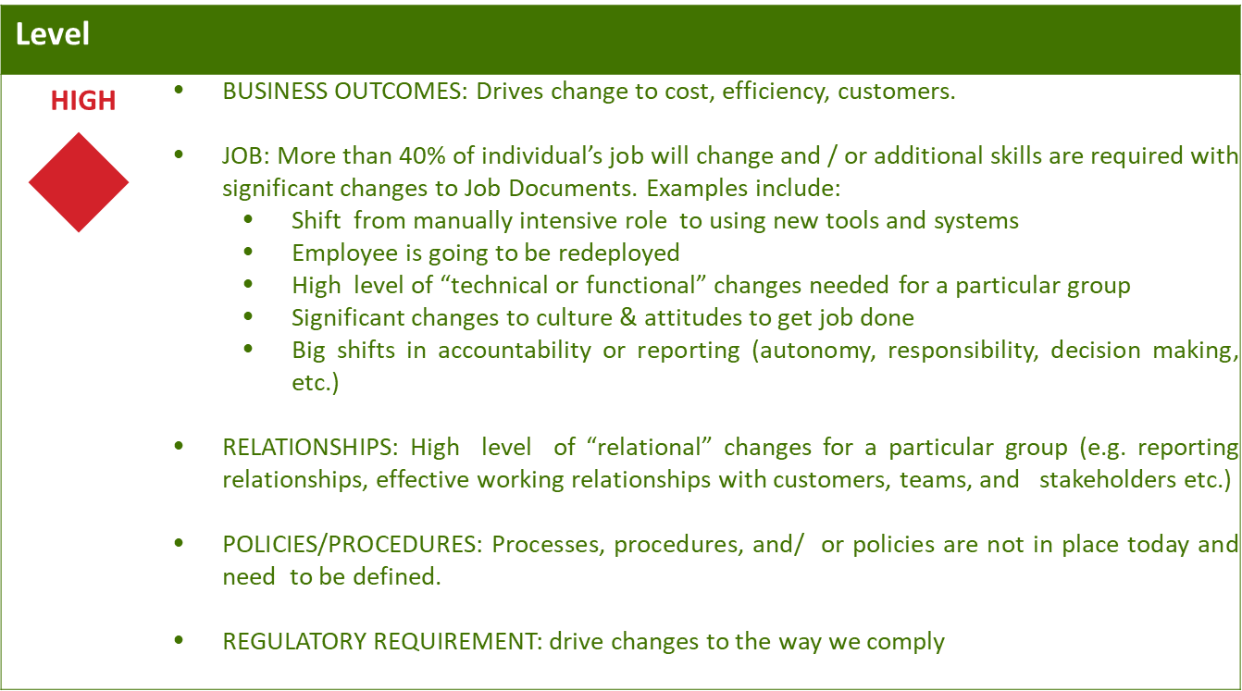
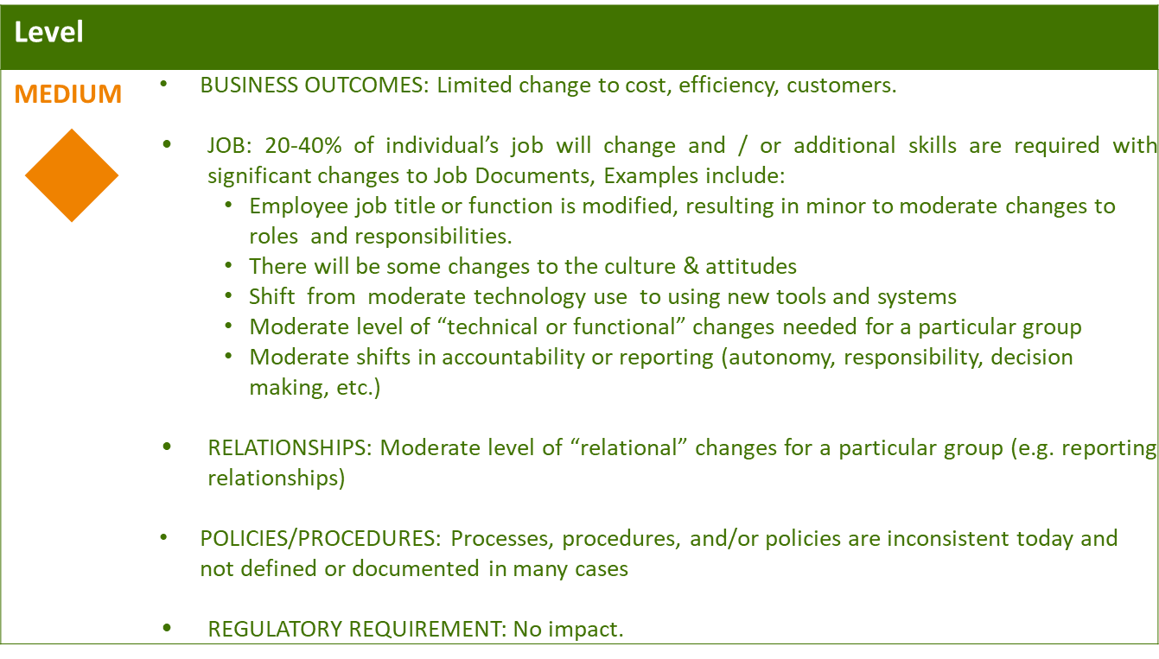
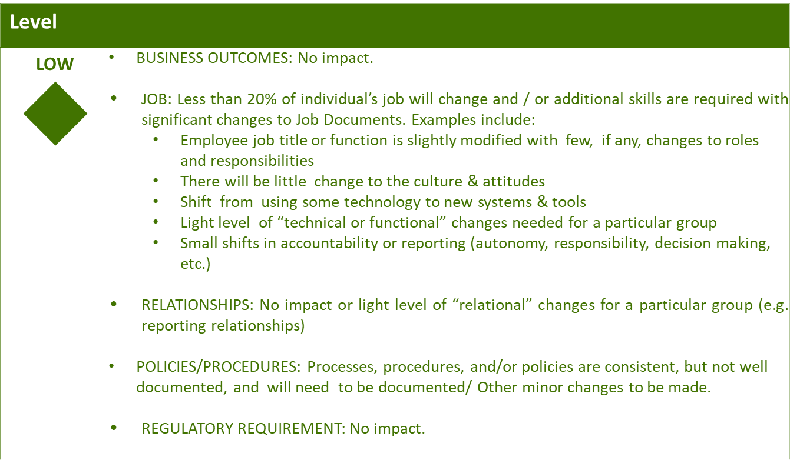

Business Effort: Initial assessment of the impact to the business High, Medium, Low

Requirements
Requirement # | APSE Requirement # | Requirement Description

